SHARE IN OUR LEARNING: Year 2 Autumn 2
English | During English this half term will be focussing on sequencing events and instructions for the reader to clearly follow. We are also going to be working on expanded noun sentences using adjectives to be able to describe a setting and characters and helping us to structure our writing better.  During all of our work we will be working hard on our handwriting and forming our letters correctly and consistently using capitals letters and full stops.
Mathematics  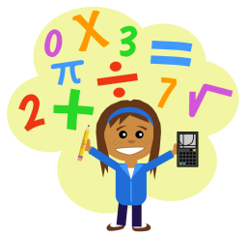 | During Maths this half term we will be looking at a number of areas including multiplication and division where we will be working on repeated addition and subtraction, arrays and grouping methods. This will lead us on to learning about fractions and finding fractions of quantities, shapes and sets of objects.  Next the topic will be Geometry covering position, direction, motion, so using our fraction skills we will be doing quarter, half, three-quarter and whole turns to the right and left.  We will also be learning how to tell and write the time to five minutes, including quarter past/to the hour and draw the hands on a clock face to show these times.  Finally, we will focus on collecting and handling data which will help us to interpret and construct simple pictograms, tally charts, block diagrams and simple tables.
Science  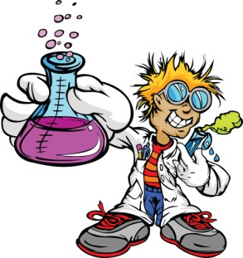 | Our Science topic this term is still ‘Animals including Humans’. The children will be carrying out investigations to find out if we get faster as we get older/bigger. They will be generating their own questions that they can answer and finding out ways that they can record and present their findings. We will also be looking at the basic needs of humans and animals, including, what we need to grow and keep healthy and designing their own healthy balanced menu.
Topic | This term’s topic is The Matchstick Man. The children will be learning about the 19th century painter LS Lowry. They will have the opportunity to explore the life and work of Lowry and to learn about the industrial landscape that provided the subject of many of his paintings. We will focus on improving key skills in art and design, comparing works of art, colour mixing, perspective and drawing figures and buildings and we will also look at the historical aspect of how the world around us has changed and compare past and present.
PE  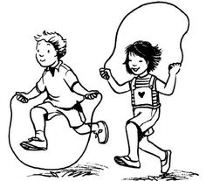 | In PE our topic for this half term is dance. The children will be considering how does the music make them feel and portraying their feelings through movement. Use the rhythm to dictate the movement. They will then be able to create a dance routine to a given piece of music
Other  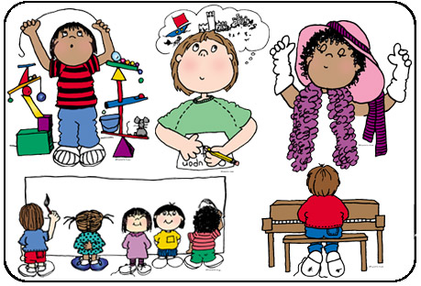 | In Music we will continuing to play the hand bells and practise our singing for the Christmas production towards the end of the term.  In Computing we are starting our coding topic where the children will create and debug simple programmes and use coding methods to control sprites and make sequential instructions. This will link in really well with our instruction writing in English and geometry within mathematics.  In RE our focus is Christianity and we will be looking at what special stories from God teaches worshippers and others? And how and why symbols show us what is important in religion?  And finally, our PSHE topic is all about respect where we will discuss and work on having respect for ourselves and others, not only within their school community but further afield and understanding that everyone can have different opinions or view points and how to be respectful of this.

