School Social Media Contract

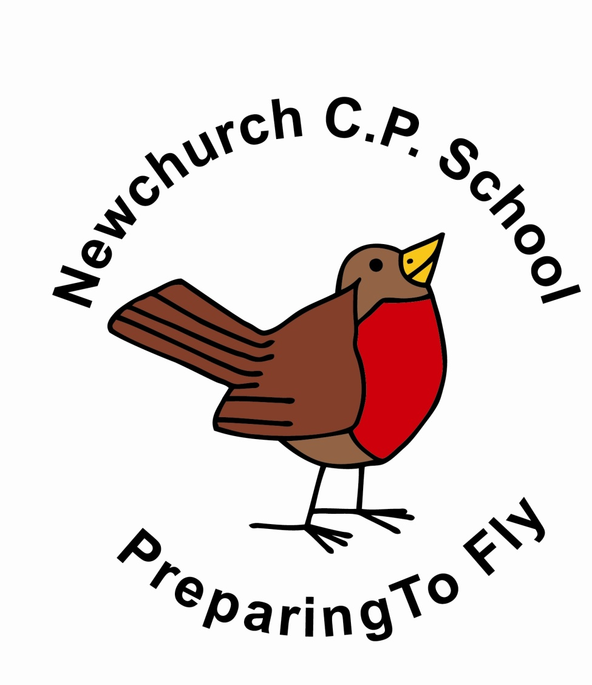

Headteacher:

Mrs S Lawrenson
Newchurch Community Primary School
Glebeland,
Culcheth,
Warrington. WA3 4DX
01925 763427
website: www.newchurchprimary.co.uk
e-mail newchurch_primary@warrington.gov.uk

Contract For Social Media

Social Media can be a very positive form of communication with adult peers, however to keep everybody safe and happy Newchurch Primary ask that you please adhere to the school’s guidelines.
‘We’ refers to all parents, carers and those who are responsible for the pupils of Newchurch Primary School.

- We may have a year group page which will have a private setting and be accessible by invite only.
- We will safeguard children to ensure that they cannot access any discussions on social media.
- We will recognise and adhere to the age restrictions which are set out by social media providers.
- We will not allow photographs of children or naming of children.
- We will not have any discussion about any events or incidents that occur in school.
- We will not make any comments that could cause offence to any child or adult.

Should Newchurch Primary read any comments, threads or discussions which do not adhere to any of the guidelines as set out above; they will act responsibly and take the appropriate action.

On signing this contract you are agreeing to ensure that all children, families and staff will be safeguarded against the misuse of social media.

Please sign and date both copies of the contract.
Please keep one copy of the contract and return the other to school.

Signed:…………………………………………………………………………………………………………

Print Name:..……………………………………..……………………………………………………..

Child’s/Children’s Name…………………………………………….……………………………

………………………………………………………………………………………………………………………

Date:.…………………………………………………………………………………………………………….

Thank you for your co-operation.
Newchurch Primary School looks forward to working together during the coming year.

Revised September 8th 2017

