SHARE IN OUR LEARNING: Year 4 Autumn A
English | Writing  - use the first 2 or 3 letters of a word to check its spelling in a dictionary  - increase the legibility, consistency and quality of their handwriting  - discussing writing similar to that which they are planning to write in order to understand and learn from its structure, vocabulary and grammar  - using commas after fronted adverbials  Reading  - Apply knowledge of root words, prefixes and suffixes to read aloud and to understand the meaning of unfamiliar words  - Discuss and record words and phrases that writers use to engage and impact on the reader  - Ask questions to improve understanding of a text  Spelling  - use further prefixes and suffixes and understand how to add them  - spell further homophones  - write from memory simple sentences, dictated by the teacher, that include words and punctuation taught so far.
Mathematics  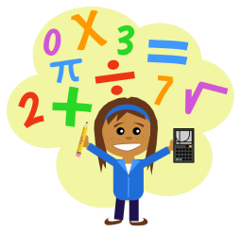 | - recognise the place value of each digit in a four-digit number (1,000s, 100s, 10s, and 1s)  - round any number to the nearest 10, 100 or 1,000  - add and subtract numbers with up to 4 digits using the formal written methods of columnar addition and subtraction where appropriate  - solve problems involving multiplying and adding, including using the distributive law to multiply two-digit numbers by 1 digit, integer scaling problems and harder
Science | States of Matter  - Compare and group materials together, according to whether they are solids, liquids or gases  - Observe that some materials change state when they are heated or cooled  - Measuring and researching the temperature at which this happens in degrees Celsius  - Identify the part played by evaporation and condensation in the Water Cycle and associate the rate of evaporation with temperature
Topic | The Groovy Greeks  - Use a range of documents and printed sources  - Distinguish between reliable and unreliable sources Identify the most useful sources for a particular task  - Describe how some things from the past affect life today  - Know some similarities and differences within a period of time- e.g. the lives of rich and poor
PE  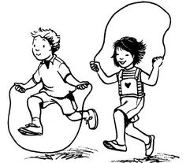 | - Developing coordination for floor movement patterns  - Increasing balance for a range of static positions and movements  - Increasing agility  - Transferring learnt skills to invasion games  - Developing confidence to attempt personal challenges
Other  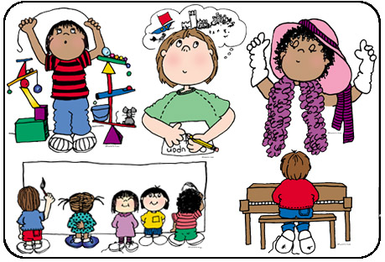 | - RE (Hindu Dharma) – What is it to do your ‘duty’?  - Computing – e-safety, creating Wiki which can be edited by their peers and added to as the project develops  - Art – Drawing  - PSHE – Respect, my identify, the people and services of our community  - Music – Gospel singing  - British Values – relating the Golden Rules and the links with different religions

