

Newchurch Community Primary School

Mathematics Policy and Building to written methods

Linked Policy Documents:

* Visual Calculation Policy
* Visual Fractions Policy
* Marking and Feedback Policy

Contents:

3 Introduction

4 How Mathematics is taught at Newchurch

5 Key Stage One key knowledge

6 Expectations for written methodology

7 Stages of Addition

8 Stages of Subtraction

9 Stages of Multiplication

11 Stages of Division

14 Year group breakdown

18 Fluency, Reasoning and Problem Solving methods – Addition

23 Fluency, Reasoning and Problem Solving methods – Subtraction

28 Fluency, Reasoning and Problem Solving methods – Multiplication

33 Fluency, Reasoning and Problem Solving methods – Division

37 End of Key Stage Two arithmetic

42 Summary

Introduction

The Mathematics framework provides a structured and systematic approach to teaching number. There is a considerable emphasis on teaching mental calculation strategies and speaking and listening activities. Up to the age of 9 (Year 4) informal written recording should take place regularly and is an important part of learning and understanding. **More formal written methods should follow only when the child is able to use a wide range of mental calculation strategies.** This will help communicate methods and solutions.

Why do we need this policy?

* Consistency in methods taught throughout the school.
* Progression from informal / practical methods of recording to written methods for each of the four operations.
* An aid to parent’s understanding in their child’s stages of learning.

Reasons for using written methods

* To aid mental calculation by writing down some of the numbers and answers involved
* To make clear a mental procedure for the pupil
* To help communicate methods and solutions
* To provide a record of work to be done
* To aid calculation when the problem is too difficult to be done mentally
* To develop and refine a set of rules for calculation

How mathematics is taught at Newchurch:

The aim of the mathematics approach is to develop the children’s mental calculation confidence before moving onto the written methods of formal mathematics. The lessons will be differentiated to meet the needs of the children, however they will work within the expectations of the National Curriculum.

The children will meet mathematics in three main formats:

1. Fluency – This is be the children’s ability to perform the base standard of the target e.g. perform a written calculation method.
2. Reasoning - The children will apply their knowledge of number and methods to more contextual problems including word problems.
3. Problem solving - The children will investigate more expansive challenges which employ their mathematics knowledge. This can include open-ended tasks and those linked to other areas of the curriculum e.g. mathematics within science.

Marking and Feedback will support the children in progressing between these three stages. They will be supported in their learning through the use of concrete manipulatives (objects), visual support (images) and finally abstract methodology.

Whole school approach

We have developed a consistent approach to the teaching of written calculation methods. This will establish continuity and progression throughout the school.

Different mental methods will be established in Key Stage 1 and built on as the children progress into Key Stage 2. These are shown below and will be based on a solid understanding of place value in number.

Things to remember for Key Stage One

1. Remembering number facts and recalling them without hesitation e.g. pairs of numbers that make 10
2. Doubles and halves to 20
3. Using known facts to calculate unknown facts

e.g. 6 + 6 = 12 therefore 6 + 7 = 13

24 + 10 = 34 therefore 24 + 9 = 33

1. Understanding and using relationships between addition and subtraction to find answers and check results

e.g. 14 + 6 = 20 therefore 20 – 6 = 14

1. Having a repertoire of mental strategies to solve calculations

e.g. 14 + 6 =20 therefore 20 – 6 = 14

bridging 10 / bridging 20

adding 9 by +10 & -1

1. Making use of informal jottings such as blank number lines to assist in calculations with larger numbers e.g. 83 – 18 = 65

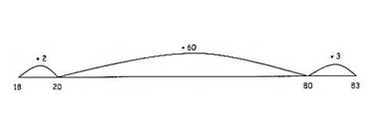

1. Solving one-step word problems (either mentally of with jottings) by identifying which operation to use, drawing upon knowledge of number bonds and explaining their reasoning
2. Beginning to present calculations in a horizontal format and explain mental steps using numbers, symbols or words
3. Learn to estimate/approximate first e.g. 29 + 30 (round to the nearest 10, the answer will be near 60)

Place value will be taught by counting on and counting back depending on the numbers.

Numbers such as 10, 100 and 1000 will be called Landmark Numbers.

When are children ready for written calculation?

Addition and Subtraction

* Do they know addition and subtraction facts to 20?
* Do they know place value and can they partition numbers in a variety of ways? E.g. 12 = 10 + 2, 12 = 9 + 3 12 = 8 + 4
* Can they add three single digit numbers mentally?
* Can they add and subtract any pair of two digit numbers mentally?
* Can they explain their mental strategies orally and record them using informal jottings?

Multiplication and Division

* Do they know their 2,3,4,5 and 10 time tables?
* Do they know the result of multiplying by 0 and 1?
* Do they understand 0 as a placeholder?
* Can they multiply two and three digit numbers 10 and 100?
* Can they double and halve two digit numbers mentally?
* Can they use multiplication facts they know to derive mentally other multiplication facts that they do not now
* Can they explain their mental strategies orally and record them using informal jottings?

**The above lists are not exhaustive but are a guide for the teacher to judge when a child is ready to move from informal to formal methods of calculation.**

Stages in Addition – (Please refer to the Visual Calculation for a more detailed breakdown)

|  |  |
| --- | --- |
| 1. Mental method, using partitioning:   47 +76 = (40 + 70) + (7 + 6)  Or  47 + 76 = (47 + 70) + 6 | 1. Introduction to vertical layout, using partitioning:   300 + 70 + 8  400 + 80 + 7  700 + 150 + 15 = 865 |
| 1. Vertical layout, expanded working, adding the least significant digit first:  |  |  | | --- | --- | | 47  + 76  13  110  123 | 368  + 493  11  150  700  861 | | |
| 1. Vertical layout, contracting the working to compact efficient form:  |  |  |  |  | | --- | --- | --- | --- | | 47  + 76  13  110  123 | 47  + 76  1 1_  123 | 368  + 493  11  150  700  861 | 368  + 493  1 1  861 | | |
| 1. Moving on to larger numbers and decimals, before moving onto more abstract forms such as algebra and fractions. | |

Stages in Subtraction – (Please refer to the Visual Calculation for a more detailed breakdown)

|  |  |  |  |  |  |
| --- | --- | --- | --- | --- | --- |
| |  |  |  |  |  | | --- | --- | --- | --- | --- | | 1. Methods using decomposition  |  |  | | --- | --- | | 89 – 65  80 9  - 60 5  20 4 = 24 | 563 -241  500 60 3  - 200 40 1  300 20 2 = 322 |   Leading to:   |  |  | | --- | --- | | 89  - 65  24 | 563  - 241  322 | | |
| 1. Vertical layout using expanded partitioning:  |  |  | | --- | --- | | 85 – 69  70 15  - 60 9  10 6 = 16 | 523 - 244  400 110 13  - 200 40 4   1. 70 9 = 279 | |
| 1. Using vertical layout, contracting the working moving to a compact efficient form:  |  |  | | --- | --- | | 85 - 69  7~~8~~15  – 69  16 | 563 -278  4~~5~~15~~6~~13  - 2 7 8  2 8 5 | |

Stages in Multiplication

To multiply successfully, children need to be able to:

• recall all multiplication facts to 10 × 10

• partition number into multiples of one hundred, ten and one

• work out products such as 70 × 5, 70 × 50, 700 × 5 or700 × 50 using the related fact 7 × 5 and their knowledge of place value

• add two or more single-digit numbers mentally

• add multiples of 10 (such as 60 + 70) or of 100 (such as 600 + 700) using the related addition fact, 6 + 7, and their knowledge of place value

• add combinations of whole numbers using the column method (see above).

**Note:** It is important that children's mental methods of calculation are practised and secured alongside their learning and use of an efficient written method for multiplication.

|  |
| --- |
| 1. Arrays. Children can start in Key Stage 1 to understand the concept of multiplications by using arrays. Arrays can help your children develop concepts of multiplication and division.   The teacher will say, “An array shows objects in rows and columns. The teacher will show an example of a row and column using an array illustration in this case cookies on a cookie sheet. (2 x 6 = 12) |
| 1. Repeated Addition:   You know, a cat has four legs. Suppose there are 3 cats. How many legs are there altogether?  The answer is 4 + 4 + 4. Using our knowledge of addition, we can find this repeated addition as 4 + 4 + 4 = 12  or 3 times 4 is 12 or 3 x 4 = 12. |
| 1. Mental Method using partitioning, multiplying tens first:   38 x 7 = (30 x 7) + (8 x 7) = 210 + 56 = 266 |
| 1. Grid Layout Method (2 digit by 1 digit):   X 30 8 210  + 55  7 210 56  266 |
| 1. Grid Layout Method (3 digit by 1 digit) i.e. 238 x 7:   X 200 30 8 1400  210  7 1400 210 56 + 56    1666 |
| 1. Grid Layout extended to bigger numbers (ThHTU)   i.e. 56 x 27 = (50 + 6) x (20 + 7)  X 50 6  20 1000 120 1120  392  7 350 42  1512 |
| 1. Vertical Format, expanded working:   38  X 7  210  56  266 |
| 1. Extended to HTU x U   Long Multiplication  56  X 27  1000 (50 x 20)  120 (6 x 20)  350 (50 x 7)  42 (6 x 7)  1512 |
| 1. Vertical Format, compact working:   56  27  1120 (56 x 20)  392 (56 x 7)  1512  1 |

Stages in Division

To introduce division it should be practical, using equipment to demonstrate. Children in Key Stage 1 are to understand division as grouping and sharing which is repeated subtraction

1. Number lines and grouping:

2 2 2 2

0 2 4 6 8

2. Informal methods using multiples of the divisor or ‘chunking’ TU ÷ U:

72 ÷ 5 72

- 50 50 = 10 x 5

22

- 20 20 = 4 x 5

**2**

**14**

Answer: 14 r 2

3. ‘Chunking’ HTU ÷ U

256 ÷ 7 256

- 70 70 = 10 x 7

186

- 140 140 = 20 x 7

46

- 42 42 = 6 x 7

4 **36**

Answer: 36 r 4

4. Efficient ‘Chunking’ HTU ÷ U

196 ÷ 6 196

- 180 180 = 30 x 6

16

- 12 12 = 2 x 6

**4** **32**

Answer: 32 r 4

5. Extending to decimals with up to 1 place

87.5 ÷ 7 87.5

- 70.0 70 = 10 x 7

17.5

- 14.0 14 = 2 x 7

3.5

- 3.5 3.5 = 0.5 x 7

**0 12.5**

Answer: 12.5

6. Chunking Extended HTU ÷ TU (Efficiently developed):

560 ÷ 24 560

- 480 480 = 20 x 24

80

- 72 72 = 3 x 24

8 **23**

Answer: 23 r 8

7. Extending to an efficient standard method:

560 ÷ 24

24 )560

- 480 20

80

-72 3

**8 23**

Answer: 23 r 8

8. Partitioning standard method:

560 ÷ 24 24 )560

10 + 10 + 3 r 8

24 240 + 240 + 80

Answer: 23 r 8

9. Extend to Compact Method

2 3 r 8

560 ÷ 24 24 )~~5~~5~~6~~860

Answer: 23 r 8

|  | Addition | Subtraction | |
| --- | --- | --- | --- |
| Y3 | TU +TU developing to HTU +TU or HTU + HTU  1. Use number lines to count on.    2. Horizontal expanded method, using partitioning.  47 +76 = (40 + 70) + (7 + 6)  Or  47 + 76 = (47 + 70) + 6  3. Vertical expanded method adding least significant digit first.  47  + 76  13  110  123 | | TU – TU, developing to HTU –TU or HTU – HTU.  1. Use a number line to count up.  15 - 9    2. Decomposition using expanded form  89 – 65  80 9  - 60 5  20 4 = 24  3. Use vertical form (expanded partitioning)  85 – 69  70 15  - 60 9  10 6 = 16 |
| Y4 | HTU + TU then HTU + HTU  1. Vertical expanded method adding least significant digit first.  47  + 76  13  110  123  2. Leading to ‘carrying’ above the line.  368  + 93  1 1  461    3. Calculations extending to include addition of two or more 3-digit sums of money.  £3.68  + 93  1 1  £4.61 | HTU – TU then HTU – HTU  1. Decomposition using expanded form.  89 – 65  80 9  - 60 5  20 4 = 24  2. Decomposition using compact form.  85 – 69  7~~8~~15  – 69  16  3. Calculations extending to include addition of two or more 3-digit sums of money.  £2~~3~~.168  - 1. 93  £ 1.75 | |
| Y5 | HTU + HTU then ThHTU + ThHTU  1. Vertical expanded method adding least significant digit first.  1,356  + 2,487  13  130  700  3000  3843  2. Leading to compact written method ‘carrying’ above the line.  1,356  2,487  1 1  3843  3. Calculations extended to include addition of two of more decimal fractions, with up to 3 digits and same number of decimal places, in vertical format | HTU – HTU the ThHTU – ThHTU  . Decomposition using expanded form.  189 – 165  100 80 9  - 100 60 5  0 60 4 = 24  2. Decomposition using compact form.  185 – 169  1 7~~8~~15  – 169  16  3. Calculations extending to include subtraction of decimals, with up to 3 digits & and the same number of decimal places, in expanded format leading to vertical format. | |
| Y6 | Th HTU + ThHTU & then any number of digits.  1. Compact written method ‘carrying’ above the line.  1,356  2,487  1  3843  2. Calculations extended to include addition of two or more decimal fractions with up to for digits & either one or two decimal places. | ThHTU – THHTU & then any number of digits  1. Decomposition using compact form.  1~~2~~,12~~3~~145  1 ,7 65  5 80  2. Calculations extended to include subtraction of two or more decimal fractions with up to 3 digits & either one or two decimal places in vertical format. | |

|  |  |  |
| --- | --- | --- |
|  | Multiplication | Division |
| KS1 | Arrays and Repeated Addition | Arrays, Number Lines Grouping and Sharing |
| Y3 | Mental Method using partitioning,  multiplying tens first:  38 x 7 = (30 x 7) + (8 x 7)  = 210 + 56 = 266  Grid Layout Method (2 digit by 1 digit):  X 30 8 210  7 210 56 + 56  266 | Informal methods using multiples of the divisor or ‘chunking’ TU ÷ U:  72 ÷ 5 72  - 50 50 = 10 x 5  22  - 20 20 = 4 x 5  **2**  **14** |
| Y4 | Grid Layout Method (3 digit by 1 digit) i.e. 238 x 7:  X 200 30 8  7 1400 210 56 1400  210  56  1666 | ‘Chunking’ HTU ÷ U  i.e 256 ÷ 7  256 ÷ 7 256  - 70 70 = 10 x 7  186  - 140 140 = 20 x 7  46  - 42 42 = 6 x 7  4 **36** |

|  |  |  |
| --- | --- | --- |
| Y5 | Grid Layout extended to bigger numbers (ThHTU)  i.e. 56 x 27 = (50 + 6) x (20 + 7)  X 50 6  20 1000 120    7 350 42 | Extending to decimals with up to 1 place  87.5 ÷ 7 87.5  - 70.0 70 = 10 x 7  17.5  - 14.0 14 = 2 x 7  3.5  - 3.5 3.5 = 0.5 x 7  **0 12.5**  Chunking Extended HTU ÷ TU (Efficiently developed):  560 ÷ 24 560  - 480 480 = 20 x 24  80  - 72 72 = 3 x 24  **8** **23** |
| Y6 | Vertical Format, expanded working:  38  X 7  210  56  266  Extended to HTU x U  Long Multiplication  56  X 27  1000 (50 x 20)  120 (6 x 20)  350 (50 x 7)  42 (6 x 7)  1512  Vertical Format, compact working:  56  X 27  1120 (56 x 20)  392 (56 x 7)  1512  1 | Extending to an efficient standard method:  560 ÷ 24  24)560  - 480 20  80  -72 3  **8 23**  Partitioning standard method:  560 ÷ 24 24)560  10 + 10 + 3 r 8  24 240 + 240 + 80  Extend to Compact Method  2 3 r 8  560 ÷ 24 24)~~5~~5~~6~~860 |

Progression in Calculations

Addition

|  |  |  |  |
| --- | --- | --- | --- |
| Objective and Strategies | Concrete | Pictorial | Abstract |
| Combining two parts to make a whole: part- whole model | Use cubes to add two numbers together as a group or in a bar.        8  1 | C:\Users\b.smith\AppData\Local\Microsoft\Windows\Temporary Internet Files\Content.IE5\2GUHBRQ0\Simple-Flower-Outline-12183-large[1].pngC:\Users\b.smith\AppData\Local\Microsoft\Windows\Temporary Internet Files\Content.IE5\2GUHBRQ0\Simple-Flower-Outline-12183-large[1].pngC:\Users\b.smith\AppData\Local\Microsoft\Windows\Temporary Internet Files\Content.IE5\2GUHBRQ0\Simple-Flower-Outline-12183-large[1].pngImage result for part whole model  C:\Users\b.smith\AppData\Local\Microsoft\Windows\Temporary Internet Files\Content.IE5\2GUHBRQ0\Simple-Flower-Outline-12183-large[1].pngC:\Users\b.smith\AppData\Local\Microsoft\Windows\Temporary Internet Files\Content.IE5\2GUHBRQ0\Simple-Flower-Outline-12183-large[1].png  Image result for part whole model addition  Use pictures to add two numbers together as a group or in a bar. | 4 + 3 = 7  10= 6 + 4  5  3  Use the part-part whole diagram as shown above to move into the abstract. |
| Starting at the bigger number and counting on | Start with the larger number on the bead string and then count on to the smaller number 1 by 1 to find the answer. | 12 + 5 = 17    Start at the larger number on the number line and count on in ones or in one jump to find the answer. | 5 + 12 = 17  Place the larger number in your head and count on the smaller number to find your answer. |
| Regrouping to make 10. | 6 + 5 = 11  Start with the bigger number and use the smaller number to make 10. | Use pictures or a number line. Regroup or partition the smaller number to make 10. | 7 + 4= 11  If I am at seven, how many more do I need to make 10. How many more do I add on now? |
| Adding three single digits | 4 + 7 + 6= 17  Put 4 and 6 together to make 10. Add on 7.    Following on from making 10, make 10 with 2 of the digits (if possible) then add on the third digit.  Add together three groups of objects. Draw a picture to recombine the groups to make 10. | C:\Users\b.smith\AppData\Local\Microsoft\Windows\Temporary Internet Files\Content.IE5\OZODVY09\pitr-Candy-icon[1].pngC:\Users\b.smith\AppData\Local\Microsoft\Windows\Temporary Internet Files\Content.IE5\OZODVY09\pitr-Candy-icon[1].pngC:\Users\b.smith\AppData\Local\Microsoft\Windows\Temporary Internet Files\Content.IE5\OZODVY09\pitr-Candy-icon[1].pngC:\Users\b.smith\AppData\Local\Microsoft\Windows\Temporary Internet Files\Content.IE5\OZODVY09\pitr-Candy-icon[1].pngC:\Users\b.smith\AppData\Local\Microsoft\Windows\Temporary Internet Files\Content.IE5\OZODVY09\pitr-Candy-icon[1].pngC:\Users\b.smith\AppData\Local\Microsoft\Windows\Temporary Internet Files\Content.IE5\OZODVY09\pitr-Candy-icon[1].pngC:\Users\b.smith\AppData\Local\Microsoft\Windows\Temporary Internet Files\Content.IE5\OZODVY09\pitr-Candy-icon[1].pngC:\Users\b.smith\AppData\Local\Microsoft\Windows\Temporary Internet Files\Content.IE5\OZODVY09\pitr-Candy-icon[1].pngC:\Users\b.smith\AppData\Local\Microsoft\Windows\Temporary Internet Files\Content.IE5\OZODVY09\pitr-Candy-icon[1].pngC:\Users\b.smith\AppData\Local\Microsoft\Windows\Temporary Internet Files\Content.IE5\OZODVY09\pitr-Candy-icon[1].pngC:\Users\b.smith\AppData\Local\Microsoft\Windows\Temporary Internet Files\Content.IE5\OZODVY09\pitr-Candy-icon[1].pngC:\Users\b.smith\AppData\Local\Microsoft\Windows\Temporary Internet Files\Content.IE5\OZODVY09\pitr-Candy-icon[1].pngC:\Users\b.smith\AppData\Local\Microsoft\Windows\Temporary Internet Files\Content.IE5\OZODVY09\pitr-Candy-icon[1].pngC:\Users\b.smith\AppData\Local\Microsoft\Windows\Temporary Internet Files\Content.IE5\OZODVY09\pitr-Candy-icon[1].pngC:\Users\b.smith\AppData\Local\Microsoft\Windows\Temporary Internet Files\Content.IE5\OZODVY09\pitr-Candy-icon[1].pngC:\Users\b.smith\AppData\Local\Microsoft\Windows\Temporary Internet Files\Content.IE5\OZODVY09\pitr-Candy-icon[1].pngC:\Users\b.smith\AppData\Local\Microsoft\Windows\Temporary Internet Files\Content.IE5\OZODVY09\pitr-Candy-icon[1].pngC:\Users\b.smith\AppData\Local\Microsoft\Windows\Temporary Internet Files\Content.IE5\OZODVY09\pitr-Candy-icon[1].pngC:\Users\b.smith\AppData\Local\Microsoft\Windows\Temporary Internet Files\Content.IE5\OZODVY09\pitr-Candy-icon[1].pngC:\Users\b.smith\AppData\Local\Microsoft\Windows\Temporary Internet Files\Content.IE5\OZODVY09\pitr-Candy-icon[1].pngC:\Users\b.smith\AppData\Local\Microsoft\Windows\Temporary Internet Files\Content.IE5\OZODVY09\pitr-Candy-icon[1].pngC:\Users\b.smith\AppData\Local\Microsoft\Windows\Temporary Internet Files\Content.IE5\OZODVY09\pitr-Candy-icon[1].pngC:\Users\b.smith\AppData\Local\Microsoft\Windows\Temporary Internet Files\Content.IE5\OZODVY09\pitr-Candy-icon[1].pngC:\Users\b.smith\AppData\Local\Microsoft\Windows\Temporary Internet Files\Content.IE5\OZODVY09\pitr-Candy-icon[1].pngC:\Users\b.smith\AppData\Local\Microsoft\Windows\Temporary Internet Files\Content.IE5\OZODVY09\pitr-Candy-icon[1].pngC:\Users\b.smith\AppData\Local\Microsoft\Windows\Temporary Internet Files\Content.IE5\OZODVY09\pitr-Candy-icon[1].pngC:\Users\b.smith\AppData\Local\Microsoft\Windows\Temporary Internet Files\Content.IE5\OZODVY09\pitr-Candy-icon[1].pngC:\Users\b.smith\AppData\Local\Microsoft\Windows\Temporary Internet Files\Content.IE5\OZODVY09\pitr-Candy-icon[1].pngC:\Users\b.smith\AppData\Local\Microsoft\Windows\Temporary Internet Files\Content.IE5\OZODVY09\pitr-Candy-icon[1].pngC:\Users\b.smith\AppData\Local\Microsoft\Windows\Temporary Internet Files\Content.IE5\OZODVY09\pitr-Candy-icon[1].png  +  +  + | Combine the two numbers that make 10 and then add on the remainder. |
| Column method- no regrouping | 24 + 15=  Add together the ones first then add the tens. Use the Base 10 blocks first before moving onto place value counters. | After practically using the base 10 blocks and place value counters, children can draw the counters to help them to solve additions.  T O |  |
| Column method- regrouping | Make both numbers on a place value grid.    Add up the units and exchange 10 ones for one 10.    Add up the rest of the columns, exchanging the 10 counters from one column for the next place value column until every column has been added.  This can also be done with Base 10 to help children clearly see that 10 ones equal 1 ten and 10 tens equal 100.  As children move on to decimals, money and decimal place value counters can be used to support learning. | Children can draw a pictoral representation of the columns and place value counters to further support their learning and understanding. | Start by partitioning the numbers before moving on to clearly show the exchange below the addition.      As the children move on, introduce decimals with the same number of decimal places and different. Money can be used here. |

Subtraction

|  |  |  |  |
| --- | --- | --- | --- |
| Objective and Strategies | Concrete | Pictorial | Abstract |
| Taking away ones | Use physical objects, counters, cubes etc to show how objects can be taken away.  6 – 2 = 4 | Cross out drawn objects to show what has been taken away. | 18 -3= 15  8 – 2 = 6 |
| Counting back | Make the larger number in your subtraction. Move the beads along your bead string as you count backwards in ones.  13 – 4  Use counters and move them away from the group as you take them away counting backwards as you go.  http://3.bp.blogspot.com/-mFqQPE4k1TE/VGzRNnUu30I/AAAAAAAAAJM/12p6qvgkmoE/s1600/EvenOdd_ColoredCounters_Scattered.jpg | Count back on a number line or number track    Start at the bigger number and count back the smaller number showing the jumps on the number line.    This can progress all the way to counting back using two 2 digit numbers. | Put 13 in your head, count back 4. What number are you at? Use your fingers to help. |
| Find the difference | Compare amounts and objects to find the difference.    Image result for two towers of cubes  Use cubes to build towers or make bars to find the difference  Use basic bar models with items to find the difference | Count on to find the difference.  http://image.slidesharecdn.com/intro-to-sm-1220840292402057-8/95/intro-to-singapore-math-13-728.jpg?cb=1345557040  Draw bars to find  the difference between 2 numbers. | Hannah has 23 sandwiches, Helen has 15 sandwiches. Find the difference between the number of sandwiches. |
| Part Part Whole Model | Link to addition- use the part whole model to help explain the inverse between addition and subtraction.  If 10 is the whole and 6 is one of the parts. What is the other part?  10 - 6 = | Use a pictorial representation of objects to show the part part whole model. | 10  5  Move to using numbers within the part whole model. |
| Make 10 | 14 – 9 =  Make 14 on the ten frame. Take away the four first to make 10 and then takeaway one more so you have taken away 5. You are left with the answer of 9. | Start at 13. Take away 3 to reach 10. Then take away the remaining 4 so you have taken away 7 altogether. You have reached your answer. | 16 – 8=  How many do we take off to reach the next 10?  How many do we have left to take off? |
| Column method without regrouping | Use Base 10 to make the bigger number then take the smaller number away.  Show how you partition numbers to subtract. Again make the larger number first. | Draw the Base 10 or place value counters alongside the written calculation to help to show working. | http://media.showmeapp.com/files/205114/pictures/thumbs/1100814/last_thumb1379615590.jpg  [https://encrypted-tbn3.gstatic.com/images?q=tbn:ANd9GcS1ohiHkzn0cS0nvwRP-5EyK0TDGl_A1tbsAl0XjNPBssTas4YVeQ](http://www.google.co.uk/url?sa=i&rct=j&q=&esrc=s&source=images&cd=&cad=rja&uact=8&ved=0CAcQjRxqFQoTCPyKt_H6h8kCFUNEFAodiFAGCA&url=http://huppiemama.com/teaching-subtraction-using-manipulatives/&bvm=bv.106923889,d.d2s&psig=AFQjCNEr_xOQu7fhwvMOMFTIen6kpdc03g&ust=1447317198959935)This will lead to a clear written column subtraction. |
| Column method with regrouping | Use Base 10 to start with before moving on to place value counters. Start with one exchange before moving onto subtractions with 2 exchanges.  Make the larger number with the place value counters  Start with the ones, can I take away 8 from 4 easily? I need to exchange one of my tens for ten ones.    Now I can subtract my ones.  Now look at the tens, can I take away 8 tens easily? I need to exchange one hundred for ten tens.    Now I can take away eight tens and complete my subtraction    Show children how the concrete method links to the written method alongside your working. Cross out the numbers when exchanging and show where we write our new amount. | Draw the counters onto a place value grid and show what you have taken away by crossing the counters out as well as clearly showing the exchanges you make.  When confident, children can find their own way to record the exchange/regrouping.  Just writing the numbers as shown here shows that the child understands the method and knows when to exchange/regroup. | Children can start their formal written method by partitioning the number into clear place value columns.  Moving forward the children use a more compact method.  This will lead to an understanding of subtracting any number including decimals. |

Multiplication

|  |  |  |  |
| --- | --- | --- | --- |
| Objective and Strategies | Concrete | Pictorial | Abstract |
| Doubling | Use practical activities to show how to double a number. | Draw pictures to show how to double a number. | Partition a number and then double each part before recombining it back together. |
| Counting in multiples | Count in multiples supported by concrete objects in equal groups. | Use a number line or pictures to continue support in counting in multiples. | Count in multiples of a number aloud.  Write sequences with multiples of numbers.  2, 4, 6, 8, 10  5, 10, 15, 20, 25 , 30 |
| Repeated addition | Use different objects to add equal groups. |  | Write addition sentences to describe objects and pictures. |
| Arrays- showing commutative multiplication | http://www.australiancurriculumlessons.com.au/wp-content/uploads/2013/05/arrays-multiplication-division-lesson.jpgCreate arrays using counters/ cubes to show multiplication sentences. | Draw arrays in different rotations to find **commutative** multiplication sentences.  http://mathcentral.uregina.ca/QQ/database/QQ.02.06/maro1.1.gif  Link arrays to area of rectangles. | Use an array to write multiplication sentences and reinforce repeated addition. |
| Grid Method | Show the link with arrays to first introduce the grid method.    4 rows of 10  4 rows of 3  Move on to using Base 10 to move towards a more compact method.  4 rows of 13  Move on to place value counters to show how we are finding groups of a number.We are multiplying by 4 so we need 4 rows.    Fill each row with 126.    Add up each column, starting with the ones making any exchanges needed.      Then you have your answer. | Children can represent the work they have done with place value counters in a way that they understand.  http://www.highviewschool.org.uk/wp-content/uploads/2014/05/IMG_0499-300x225.jpgThey can draw the counters, using colours to show different amounts or just use circles in the different columns to show their thinking as shown below. | Start with multiplying by one digit numbers and showing the clear addition alongside the grid.  http://www.mumsnet.com/system/1/assets/files/000/006/988/6988/35010b289/original/328x164xgrid-method-explained-2.jpg.pagespeed.ic.zL-KyDdiL2.jpg  Moving forward, multiply by a 2 digit number showing the different rows within the grid method. |
| Column multiplication | https://primarysite-prod.s3.amazonaws.com/0c4eb252d34643748228179a3d582154_1x1.jpegChildren can continue to be supported by place value counters at the stage of multiplication.  It is important at this stage that they always multiply the ones first and note down their answer followed by the tens which they note below. | Bar modelling and number lines can support learners when solving problems with multiplication alongside the formal written methods.  C:\Users\nathan.crook\AppData\Local\Microsoft\Windows\Temporary Internet Files\Content.Outlook\3IR2FLXR\photo (5).JPG  C:\Users\nathan.crook\AppData\Local\Microsoft\Windows\Temporary Internet Files\Content.Outlook\3IR2FLXR\photo (7).JPG | Start with long multiplication, reminding the children about lining up their numbers clearly in columns.  If it helps, children can write out what they are solving next to their answer.  http://ictedusrv.cumbria.ac.uk/maths/SecMaths/U1/images/pic018.gif    This moves to the more compact method.  http://amsi.org.au/teacher_modules/B1/B1t102.png |

Division

|  |  |  |  |
| --- | --- | --- | --- |
| Objective and Strategies | Concrete | Pictorial | Abstract |
| Sharing objects into groups | I have 10 cubes, can you share them equally in 2 groups? | Children use pictures or shapes to share quantities.  C:\Users\b.smith\AppData\Local\Microsoft\Windows\Temporary Internet Files\Content.IE5\C9ORAZE7\Simple-Flower-Outline-12183-large[1].pngC:\Users\b.smith\AppData\Local\Microsoft\Windows\Temporary Internet Files\Content.IE5\C9ORAZE7\Simple-Flower-Outline-12183-large[1].pngC:\Users\b.smith\AppData\Local\Microsoft\Windows\Temporary Internet Files\Content.IE5\C9ORAZE7\Simple-Flower-Outline-12183-large[1].pngC:\Users\b.smith\AppData\Local\Microsoft\Windows\Temporary Internet Files\Content.IE5\C9ORAZE7\Simple-Flower-Outline-12183-large[1].pngC:\Users\b.smith\AppData\Local\Microsoft\Windows\Temporary Internet Files\Content.IE5\C9ORAZE7\Simple-Flower-Outline-12183-large[1].pngC:\Users\b.smith\AppData\Local\Microsoft\Windows\Temporary Internet Files\Content.IE5\C9ORAZE7\Simple-Flower-Outline-12183-large[1].pngC:\Users\b.smith\AppData\Local\Microsoft\Windows\Temporary Internet Files\Content.IE5\C9ORAZE7\Simple-Flower-Outline-12183-large[1].pngC:\Users\b.smith\AppData\Local\Microsoft\Windows\Temporary Internet Files\Content.IE5\C9ORAZE7\Simple-Flower-Outline-12183-large[1].png  8 ÷ 2 = 4 | Share 9 buns between three people.  9 ÷ 3 = 3 |
| Division as grouping | Divide quantities into equal groups.  Use cubes, counters, objects or place value counters to aid understanding. | Use a number line to show jumps in groups. The number of jumps equals the number of groups.    http://gcamath3.weebly.com/uploads/9/1/4/0/9140392/200455_orig.jpgThink of the bar as a whole. Split it into the number of groups you are dividing by and work out how many would be within each group. | 28 ÷ 7 = 4  Divide 28 into 7 groups. How many are in each group? |
| Division within arrays | Link division to multiplication by creating an array and thinking about the number sentences that can be created.  Eg 15 ÷ 3 = 5 5 x 3 = 15  15 ÷ 5 = 3 3 x 5 = 15 | Draw an array and use lines to split the array into groups to make multiplication and division sentences. | Find the inverse of multiplication and division sentences by creating four linking number sentences.  7 x 4 = 28  4 x 7 = 28  28 ÷ 7 = 4  28 ÷ 4 = 7 |
| Division with a remainder | 14 ÷ 3 =  Divide objects between groups and see how much is left over  Image result for counters | Jump forward in equal jumps on a number line then see how many more you need to jump to find a remainder.  Draw dots and group them to divide an amount and clearly show a remainder. | Complete written divisions and show the remainder using r.  http://amsi.org.au/teacher_modules/G7/G7_qt2%202.png |
| Short division | Use place value counters to divide using the bus stop method alongside  42 ÷ 3=  Start with the biggest place value, we are sharing 40 into three groups. We can put 1 ten in each group and we have 1 ten left over.    We exchange this ten for ten ones and then share the ones equally among the groups.  We look how much in 1 group so the answer is 14. | http://www.studyzone.org/testprep/math4/d/division2.gifStudents can continue to use drawn diagrams with dots or circles to help them divide numbers into equal groups.  Encourage them to move towards counting in multiples to divide more efficiently. | Begin with divisions that divide equally with no remainder.  Move onto divisions with a remainder.  Finally move into decimal places to divide the total accurately. |

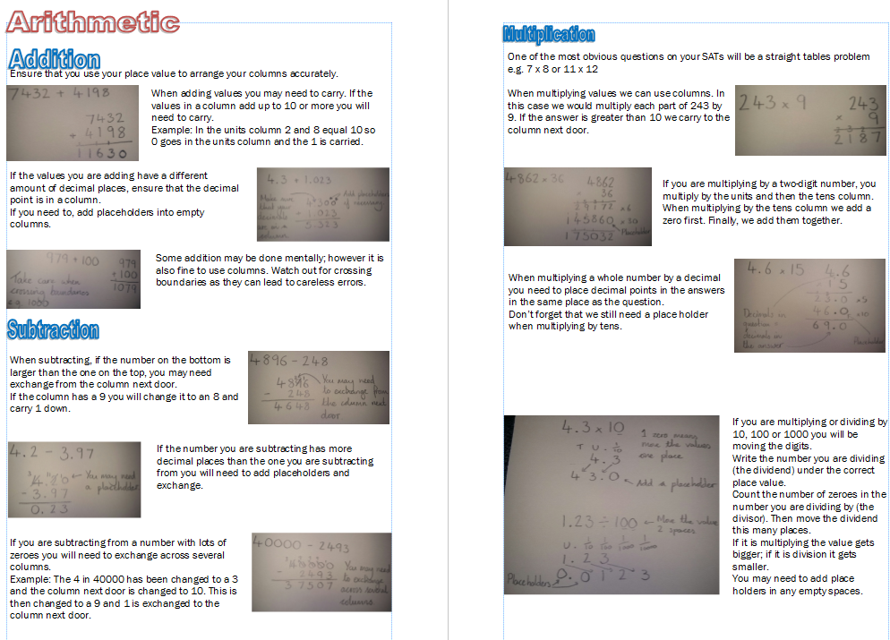

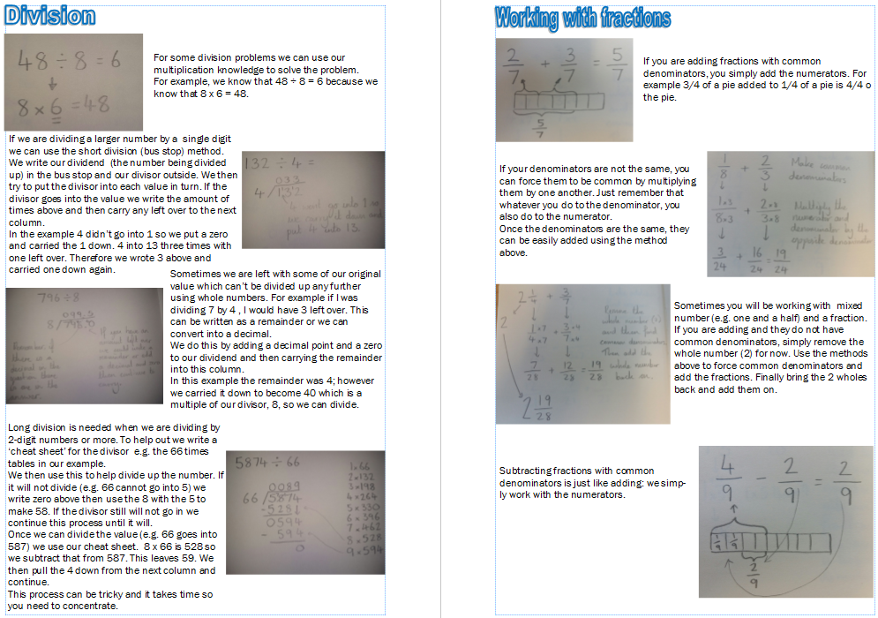

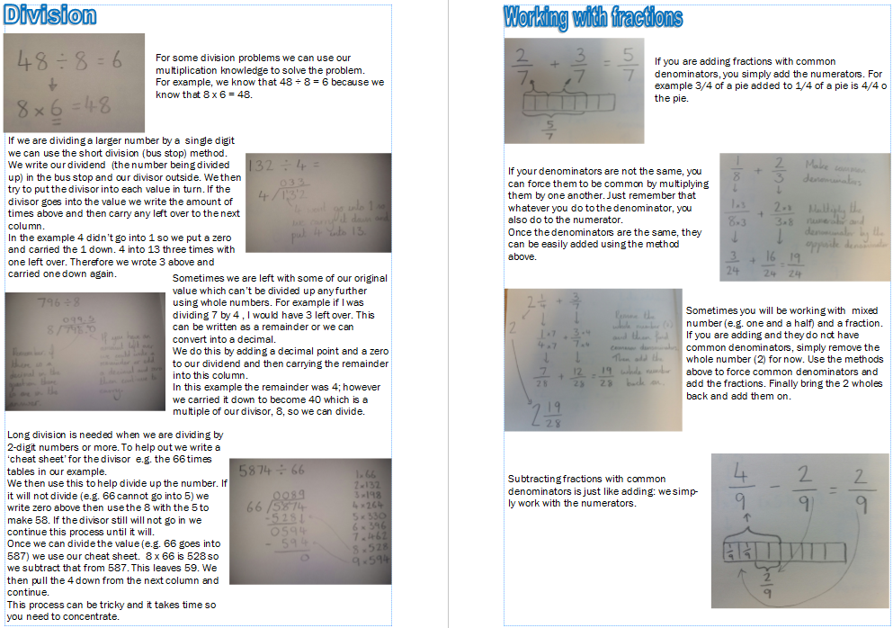

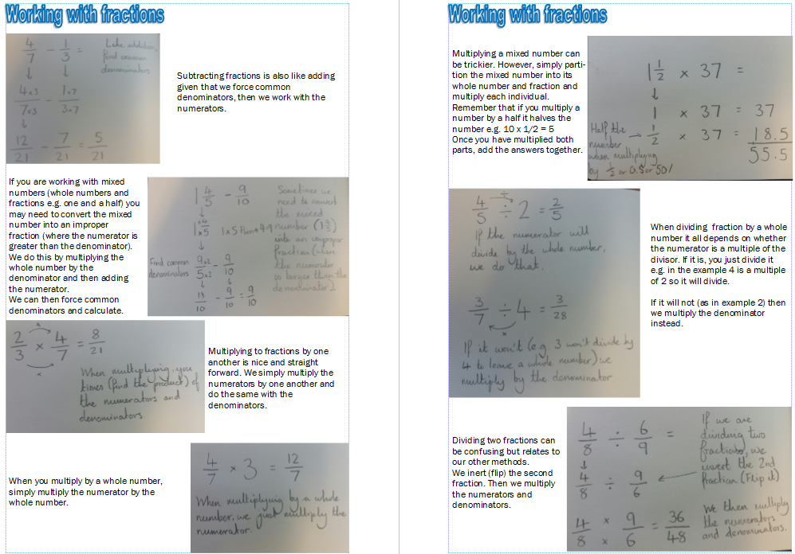

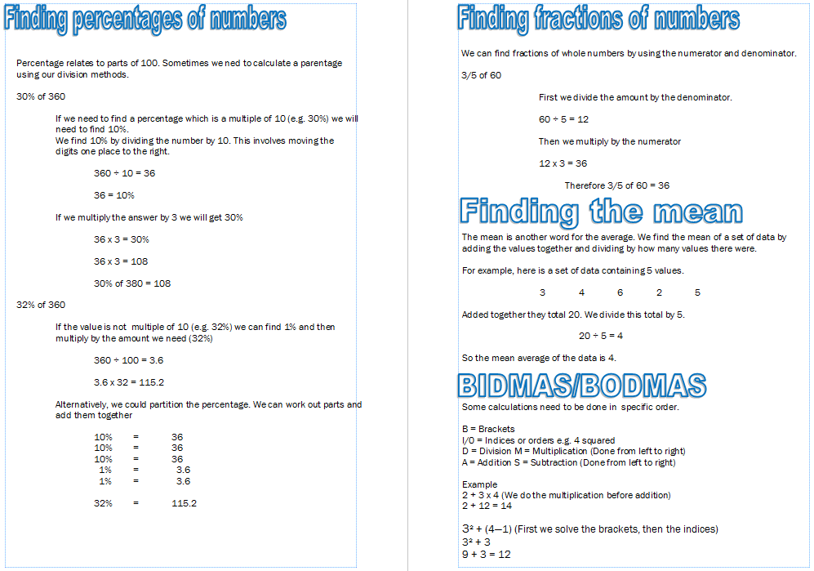

Summary

* Progression is made when pupils are ready, though age related expectation will be followed throughout the school in line with the National Curriculum.
* The children will cover mathematics in three stages of understanding: fluency, reasoning and problem solving.
* Children should be persuaded to estimate first.
* Always check the answer, preferably using a different method e.g. inverse operation.
* Pay attention to language – refer to actual value of digits.
* Children who make persistent mistakes should return to the method that they can use accurately until ready to move on. They will also be supported by the use of manipulatives and concrete objects.
* Children need to know number and multiplication facts by heart.
* Discuss errors and diagnose problems and then work through problem – do not simply re-teach method.
* When revising or extending to more challenging or larger numbers, refer back to expanded methods. This helps reinforce understanding and reminds children that they have an alternative to fall back on if they are having difficulties.