SHARE IN OUR LEARNING: Year 5 Autumn A
English | Traditional Tales – Legends  Write a British legend focusing on effective characterisation  •Express a personal point of view about a text, giving rea sons.  • Make predictions from what has been read.  •Draw inferences  • Use a thesaurus to develop vocabulary  • Relative clauses/relative pronouns  • Proofread for spelling and punctuation errors  Report Writing  Write a report in the form of an information leaflet  •Use knowledge of structure of text type to find key information.  •Use text marking to identify key information in a text.  •Make notes from text marking.  • Noting and developing initial ideas, drawing on reading and research where necessary  • Using further organisational and presentational devices to structure text and to guide the reader  Spelling rule  ‘tious’ ‘cious’
Mathematics | Number and Place Value  Addition and Subtraction  Factors and Prime numbers  Multiplication and division  Angles  Length, Perimeter and Area
Science | Living things and their habitats throughout the year  - Describing the differences in the life cycles of a mammal, an amphibian, an insect and a bird  - Describe the life process of reproduction in some plants and animals  - Working scientifically
Topic | A Kingdom United  - Britain’s settlement by Anglo-Saxons and Scots  - The Viking and Anglo-Saxon struggle for the Kingdom of England to the time of Edward the Confessor  - Countries and cities of the United Kingdom
PE  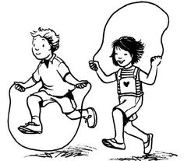 | REAL PE  Tennis  - Hitting and receiving a ball with control  - Use correct racket grip  - Apply skills, and actions and ideas with increasing coordination and control  - Start to play competitive games and apply basic principles suitable for attacking and defending.
Other  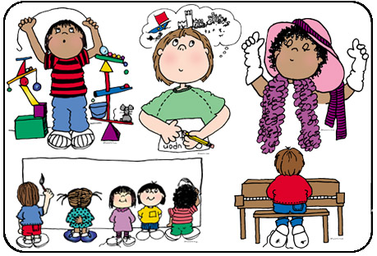 | - RE (Hinduism) – What different kinds of writings and stories are important to beliefs/religions?  - Computing – Web designers (understanding the opportunities networks offer for communication and collaboration and evaluating digital content)  - Music – guitars  - Art – Anglo-Saxon drawings, making a clay Diwali lamp  - PHSE – Respect, levels of friendship, our links around the world  - British Values – What happens when civil law and religious laws clash?

