Newchurch Primary School Visual Art Overview
Year Group | Drawing | Painting | Printing | Textiles | Collage/Mixed Media | Sculpture/3D
EYFS | - Begin to use a variety of drawing tools  - Use drawings to tell a story Investigate different lines  - Explore different textures Encourage accurate drawings of people  Artist Link –Quentin Blake  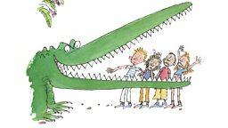 | - Experimenting with and using primary colours  - Naming colours  - Mixing colours (not formal)  - Learn the names of different tools that bring colour  - Use a range of tools to make coloured marks on paper  Artist Link – Albert Irvin  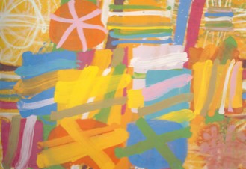 | - Rubbings  - Print with variety of objects  - Print with block colours  Artist Link – Frottage (Art form)  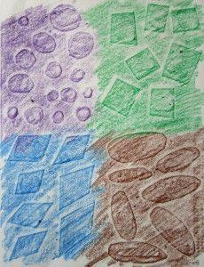 | - Handling, manipulating and enjoying using materials  - Sensory experience  - Simple weaving  Artist Link – Ulrike Martin  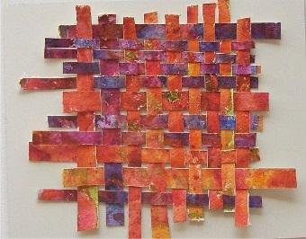 | - Repeating patterns  - Irregular painting patterns  - Simple symmetry  Artist Link – Basic symmetry  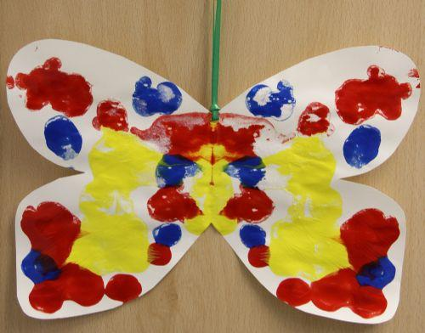 | - Handling, feeling, enjoying and manipulating materials  - Constructing  - Building and destroying  - Shape and model  Artist Link – Building blocks  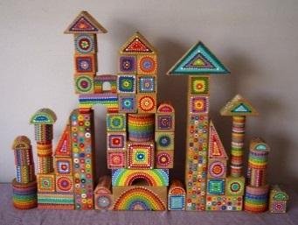
Vocab | Line – A mark made which is longer than it is wide but which denotes a boundary.  Texture – In a work of art, the tactile qualities of a 3D surface or representation of such qualities. Can we make something look rough or smooth, soft or hard?  Colour - The use of hue (name for a colour e.g. red) to mark specific areas in a drawing or painting | As previous disciplines, plus…  Mixing – Means by which various colours are made.  Palette - Essential for colour-painting, an artist's palette refers to (1) The instrument the artist mixes their colours on. (2) The colours the artist chooses to use.  Brush – Most common means for applying paint to a surface. | As previous disciplines, plus…  Rubbing/Frottage – The act of gaining a pattern or image from rubbing a colour over a piece of paper placed on the object. | As previous disciplines, plus…  Plain weaving – The act of interlacing threads to form a fabric.  Thread/strips – the individual pieces which are woven together. | As previous disciplines, plus…  Symmetry – The act of balancing two sides of an image so that they are a reflection of one another.  Pattern – Organised structure in a piece. This can be repetition of shape or form. | As previous disciplines, plus…  Constructing – The act of building through piecing together objects.  Model – To create work through construction.

One | - Extend the variety of drawings tools  - Explore different textures  - Observe and draw landscapes  - Observe patterns  - observe anatomy (faces, limbs)  Artist Link - Paul Klee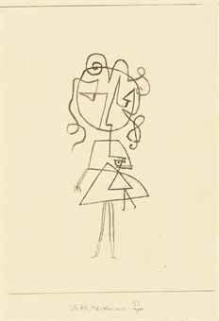 | - Name all the colours mixing of colours  - Find collections of colour  - Applying colour with a range of tools  Artist Link – Wassily Kandinsky  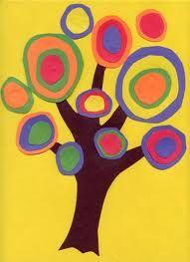 | - Create patterns  - Develop impressed images  - Relief printing  Artist Link – Henri Matisse  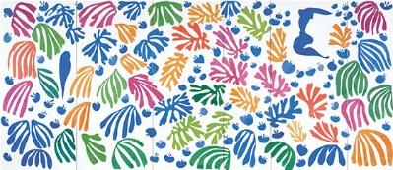 | - Weaving.  - Sort according to specific qualities.  - How textiles create things.  Artist Link – Complex weaving  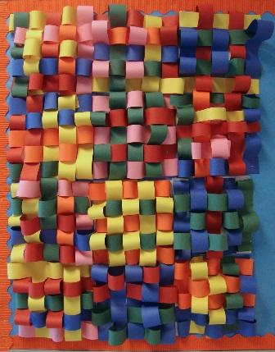 | - Awareness and discussion of patterns  - Repeating patterns  - Symmetry  Artist Link – Pattern making  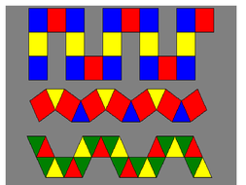 | - Construct  - Use materials to make known objects for a purpose  - Carve  - Pinch and roll coils and slabs using a modelling media.  - Make simple joins  Artist Link – Manipulating materials  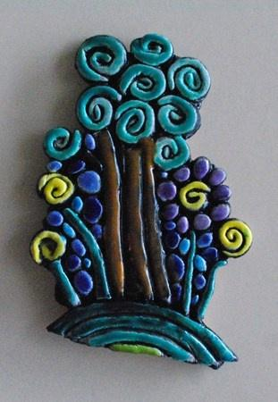

Vocab | As EYFS, plus…  Pattern – Organised structure in a piece. This can be repetition of shape or form.  Tone - A term used in art to refer to the lightness or darkness of a colour. | As previous year groups and disciplines, plus…  Primary colour – Red, blue and yellow (cannot be obtained by mixing)  Secondary colour – Green, orange, purple (created by mixing two of the primary colours).  Warm and cold colours – Colours which give the viewer a sense of warmth or cold. | As previous year groups and disciplines, plus…  Impress – Make a mark into an object which can then be used for printing.  Relief - A technique in which the image is printed from a raised surface.  Block - A piece of thick, flat material, with a design on its surface, used to print repeated impressions of that design.  Brayer - A small roller used to spread printing ink evenly on a surface before printing. | As previous year groups and disciplines, plus…  Properties – The way in which a material behaves or acts under certain conditions e.g. stretchy.  Twill weave – Twill is a type of textile weave with a pattern of diagonal parallel ribs (in contrast with a satin and plain weave). This is done by passing the weft thread over one or more warp threads then under two or more warp threads and so on, with a "step," or offset, between rows to create the characteristic diagonal pattern.  Satin weave - Satin is a weave that typically has a glossy surface and a dull back, one of three fundamental types of textile weaves along with plain weave and twill. The satin weave is characterized by four or more fill or weft yarns floating over a warp yarn, four warp yarns floating over a single weft yarn.  Warp and weft - The two basic components used in weaving to turn thread or yarn into fabric. The lengthwise or longitudinal warp yarns are held stationary in tension on a frame or loom while the transverse weft (sometimes woof) is drawn through and inserted over-and-under the warp. | As previous year groups and disciplines, plus…  Repeating patterns – When familiar shapes, colours or forms are used regularly and systematically. | As previous year groups and disciplines, plus…  Carve – The act of cutting into a material to create an image or object.  Joins – Ways in which parts are pieced together.  Pinch and roll – Methods for interacting with modelling materials.

Two | - Experiment with tools and surfaces  - Draw a way of recording experiences and feelings  - Discuss use of shadows, use of light and dark  - Sketch to make quick records  Artist Link – Patrick Caulfield  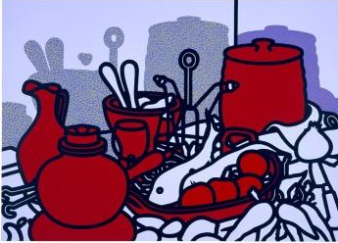 | - Begin to describe colours by objects  - Make as many tones of one colour as possible (using white)  - Darken colours without using black using colour on a large scale  Artist Link – L.S. Lowry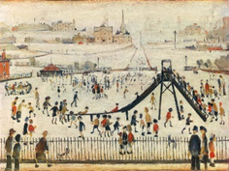 | - Print with a growing range of objects  - Identify the different forms printing takes  Artist Link – Charles Rennie Mackintosh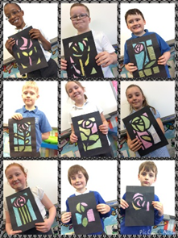 | - Overlapping and overlaying to create effects  - Use large eyed needles –running stitches  - Simple appliqué work  - Start to explore other simple stitches collage  Artist Link – Gustav Klimt  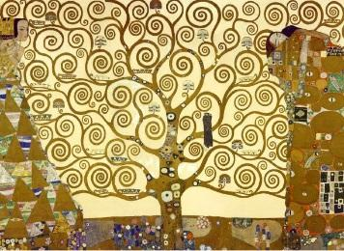 | - Experiment by arranging, folding, repeating, overlapping, regular and irregular patterning  - Natural and manmade patterns  - Discuss regular and irregular  Artist Link – Guillermo Kuitca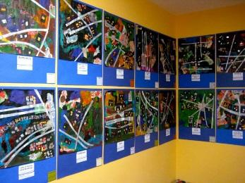 | - Awareness of natural and man-made forms  - Expression of personal experiences and ideas  - To shape and form from direct observation (malleable and rigid materials)  - Decorative techniques  - Replicate patterns and textures in a 3-D form  - Investigate the work of other sculptors  Artist Link –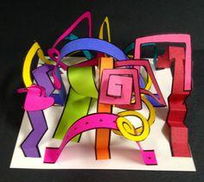
Vocab | As previous year groups, plus…  Composition - The arrangement of visual elements such as lines, spaces, tones, and colours in a work of art (where you place things on the page)  Aesthetic – The idea of beauty in art – things we enjoy looking at.  Shade – Marks made to suggest a difference in lightness or value. | As previous year groups and disciplines, plus…  Tertiary colour – Colour gained by the mixing of a primary and secondary colour.  Tone - A term used in art to refer to the lightness or darkness of a colour.  Lighten and darken – The act of changing the tone of a colour either through adding black and white or a colour deemed lighter or darker than the initial one e.g. adding purple to red will darken it.  Monochrome – Consisting of just one colour. | As previous year groups and disciplines, plus…  Mezzotint - This is a very beautiful but time-consuming technique, which was most popular in the 18th and 19th centuries for portraiture and reproducing other works of art. In creating a mezzotint, first the entire metal plate is roughened by marking fine lines into the plate in all directions with a rocker (If printed at this stage, the entire paper would be black). Tones are created by burnishing or scraping into the plate, working from black back to middle values and highlights thus allowing the print to have continuous tonal range.  Woodcut - Woodcut is one of the oldest and simplest forms of printmaking. Various implements (both hand tools and power tools) can be used to cut the image into a block of wood. Paper is placed over the inked block and rubbed by hand or passed through a press to transfer the ink from block to paper to create the image  Etching - This process uses acid to bite an image into a metal plate that is coated with an acid-resistant ground. A sharp needle is used to scratch the image through the ground, exposing the metal. The plate is then immersed in an acid bath where the drawn marks are etched.  Engraving - For this technique, a metal plate is incised with a tool called a burin. Great skill is required to manipulate the burin as it is pushed at different angles and degrees of pressure to produce a characteristic thin to thick line. Engraving techniques were used by the Greeks, Romans and Etruscans for decorating objects but were not used for printmaking until the mid 15th century in Germany. Engraved images are comprised of a multitude of crisp, fine lines. Shading is traditionally rendered by multiple parallel lines or cross-hatching.  Linocut - The linoblock consists of a layer of linoleum, usually mounted on a block of wood. This soft material is easily carved using knives and gouges. The image is then printed as with a woodcut. | As previous year groups and disciplines, plus…  Appliqué - When one shape of fabric is sewn on top of another piece of fabric, it can be attached using hand stitching or zig-zag machine stitch.  Eye – The hole at the top of a needle.  Needle – A metal tool used to pass a thread through a piece of fabric.  Cotton – Thread of material often used for stitching.  Wool – Thicker strand of material used in knitting.  Knitting – The act of creating fabric by interlacing strands of wool. | As previous year groups and disciplines, plus…  Man-made – Objects created by humanity.  Natural – Objects which appear in nature and have not been made by man.  Regular and irregular – Objects repeated in exact pattern and spacing or not.  Arranging – The act of specifically positioning objects in a piece of work.  Folding – The act of making creases in a material by bending.  Overlapping – The act of placing one material over another. | As previous year groups and disciplines, plus…  Man-made and natural forms – Recognising the shapes which the structure takes up e.g. straight lines, natural curves.  Malleable - Able to be hammered or pressed into shape without breaking or cracking.  Rigid - Unable to bend or be forced out of shape; not flexible.  Sculptor – Artist who works in three dimensions.

Three | - Experiment with the potential of various pencils Make close observation  - Draw both the positive and negative shapes  - Initial sketches as a preparation for painting accurate drawings of people – particularly faces  Artist Link –Tang YauHoong  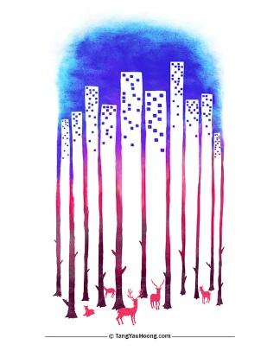 | - Colour mixing  - Make colour wheels  - Introduce different types of brushes techniques- apply colour using dotting, scratching, splashing  Artist Link – Georges Seurat  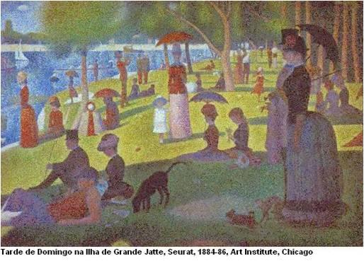 | - Relief and impressed printing  - Recording textures/patterns  - Mono-printing  - Colour mixing through overlapping colour prints  Artist Link – FriedensreichHundertwasser  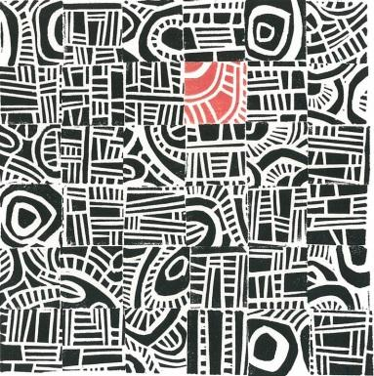 | - Use smaller eyed needles and finer threads  - Weaving  - Tie dying, batik  Artist Link – Michael Phelan 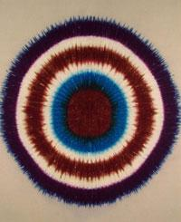 | - Pattern in the environment design  - Using ICT  - Make patterns on a range of surfaces  - Symmetry  Artist Link – Ted Harrison  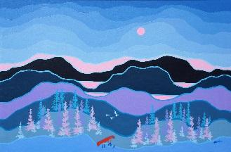 | - Shape, form, model and construct ( malleable and rigid materials)  - Plan and develop  - Understanding of different adhesives and methods of construction  - Aesthetics  Artist Link - Alexander Calder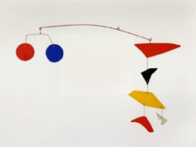
Vocab | As previous year groups, plus…  Form - The physical characteristics of an artwork which include line, shape, texture value, and colour, in opposition to intellectual or emotional content  Space - The area the artist uses for a specific purpose. Can be negative space (around, through between, within objects) or positive space (area taken up by an object) | As previous year groups and disciplines, plus…  Brushstroke – The act of applying paint to a surface.  Pointillism – Arts movement focusing on applying paint through small dots to build a bigger image.  Removal/erasing – The act of removing paint from the surface as part of the creative process.  Colour wheel – a system for representing and recognising the primary, secondary and tertiary colours. | As previous year groups and disciplines, plus…  Mono-printing – The act of creating just one print version of a piece.  Overlapping – Placing one colour print over a differing colour for effect.  Collagraph - A print made from an image built up with glue and other collage-type materials.  Screen Print - A form of stencil printing in which the stencil is adhered to a fine screen for support. | As previous year groups and disciplines, plus…  Tie-dye – Form of textiles work where parks of the material are bound before immersing in dye. When removed and dried they create various patterns.  Batik – Artform from Asia where a resistant material is added to the textiles e.g. wax before painting or dying. This is then removed to reveal the pattern. | As previous year groups and disciplines, plus…  Motif – An image or element of the piece which recurs giving it a sense of importance to the overall piece.  Collage - An artistic composition made of various materials (e.g., paper, cloth, or wood) glued on a surface.  Multimedia - Computer programs that involve users in the design and organization of text, graphics, video and sound in one presentation. | As previous year groups and disciplines, plus…  Aesthetics - The idea of beauty in art – things we enjoy looking at.  Adhesives – Materials used for the joining of objects.  Concave - Surfaces that are hollow or curved inward.  Convex – Surfaces which are curved outward.

Four | - Identify and draw the effect of light scale and proportion.  - Accurate drawings ofwhole people including proportion and placement.  - Work on a variety of scales.  - Computer generated drawings.  Artist Link – Jim Lee (Link to Ancient Greek figurative drawing)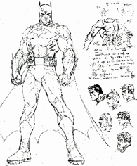 | - Colour mixing and matching; tint, tone, shade  - Observe colours  - Suitable equipment for the task  - Colour to reflect mood  Artist Link – Georges Braque  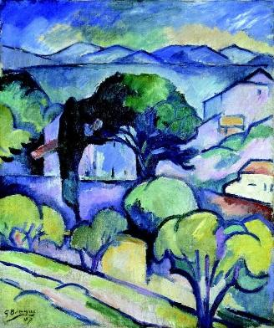 | - Use sketchbook for recording textures/patterns  - Interpret environmental and manmade patterns  - Modify and adapt print  Artist Link – Dan Mather  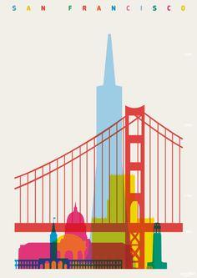 | - Use a wider variety of stitches.  - Observation and design of textural art.  - Experimenting with creating mood, feeling, movement  - Compare different fabrics  Artist Link – Rosie James  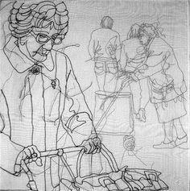 | - Explore environmental and manmade patterns  - Tessellation  Artist Link - M.C. Escher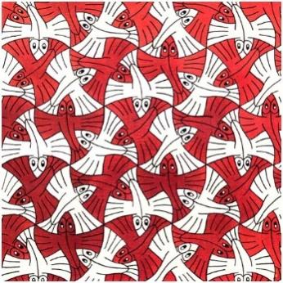 | - Plan and develop.  - Experience surface patterns/textures.  - Discuss own work andwork of other sculptors.  - Analyse and interpret natural and man-made forms of construction.  Artist Link – Andy Goldsworthy  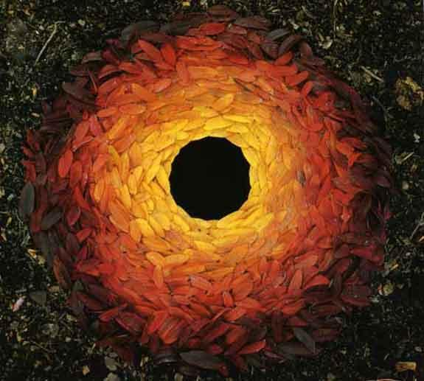
Vocab | As previous year groups, plus…  Proportion – The relative size of parts of a whole e.g. the size of the eye compared to the nose or head as a whole.  Scale – The relative size of an object linked to others when made larger or smaller in the drawing process. | As previous year groups and disciplines, plus…  Tint - a shade or variety of a colour.  Shade - a colour, especially with regard to how light or dark it is or as distinguished from one nearly like it.  Mood – The feelings which a piece creates in the viewer. Often achieved through subject matter and colour choices.  Impressionism – Arts movement including Cezanne, Monet et al which focused on representing the light within an image – often seemed changeable.  Medium  The method in which an artist works; oil-painting, gouache, pastel, pen and ink, etching, collage, sculpture, etc. | As previous year groups and disciplines, plus…  Modify and adapt – to make changes to the position of printed elements in order to alter the composition etc.  Stencil - A printing process by which areas are blocked out to keep ink from non-image areas. | As previous year groups and disciplines, plus…  Fabric – A type of cloth produced by knitting or weaving.  Hand embroidery - Using a needle and thread to create patterns or pictures or word with stitches | As previous year groups and disciplines, plus…  Tessellation - An arrangement of shapes closely fitted together, especially of polygons in a repeated pattern without gaps or overlapping. | As previous year groups and disciplines, plus…  Environmental – Art which interacts with or exists as part of the world around it.  Additive – Sculpture made by adding material.

Five | - Develop direction of light and effect on objects.  - Draw and adapt images of people with accurate proportions.  - Begin to consider how texture can be interpreted.  Artist Link - Roy Lichtenstein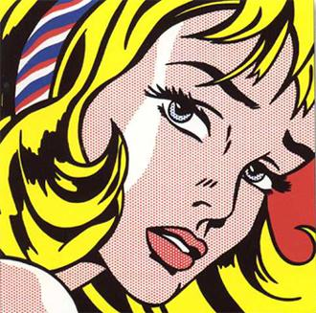 | - Hue, tint, tone, shades and mood.  - Explore the use of texture in colour.  - Colour for purposes.  Artist Link – J.M.W. Turner  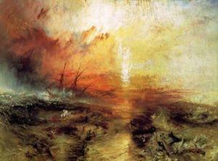 | - Combining prints design prints.  - Make connections.  - Discuss and evaluate own work and that of others.  Artist Link –Andy Warhol 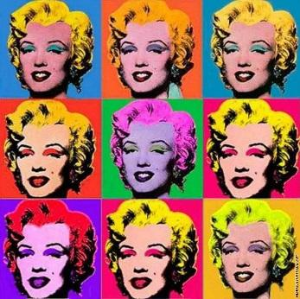 | - Use stories, music, poems as stimuli  - Select and use materials  - Embellish work  - Fabric making  - Artists using textiles  Artist Link – Linda Calverley  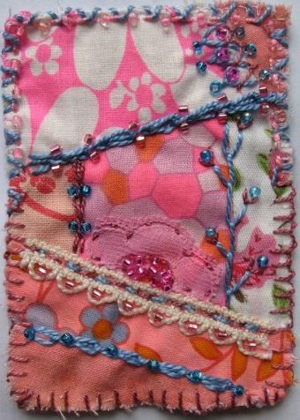 | - Create repeating patterns which express a mood or feeling.  - Use a variety of materials to add depth to images.  - Consider how colour can be used to add depth.  Artist Link – Alma Woodsey Thomas  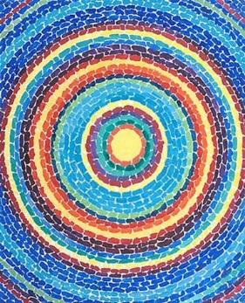 | - Plan and develop ideas  - Shape, form, model and join  - Observation or imagination  - Properties of media  - Discuss and evaluate own work and that of other sculptors  Artist Link – Claes Oldenburg  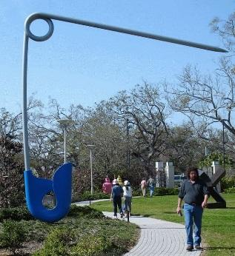
Vocab | As previous year groups, plus…  Contour - The perceived edges of any 3D form  Contrast – The deliberate choice to place opposite elements together in a piece e.g. light and dark, rough and smooth, large and small | As previous year groups and disciplines, plus…  Texture – the tactile quality of the surface of an artwork.  Hue – Form of colour  Blending  A term concerned mostly with oils, acrylics or alkyds. It implies the softening of hard edges between colours, and the artist would be likely to use a fan brush or the tip of a finger.  Grading  The handling of a water-colour wash to give it a lightening or darkening effect as the colour flows down the paper. This is done by adding water to the bowl of colour or more colour.  Ground  The name that is applied to the coating of the surface on which the painting is to be carried out.  Landscape Painting  Scenic views with no significant human figures or activity.  Portrait Art  Individual or group or self-portraits – pictures of people.  Wash  The application of dilute water-colour to a support. | As previous year groups and disciplines, plus…  Combining – Using a range of images to create a larger whole piece.  Mass production – When artwork is reproduced on a large scale beyond a single copy.  Edition – Series of prints of a single image.  Popular culture/Pop art – The movement lined to the use of mass produced works commenting on modern culture at the time. | As previous year groups and disciplines, plus…  Embellishment – The act of stitching objects to the material e.g. sequins, buttons etc.  Sequins – Small plastic discs which are often reflective or shiny which can be sewn onto material. | As previous year groups and disciplines, plus…  Depth – Act of adding variety of form or colour to create a sense of foreground. | As previous year groups and disciplines, plus…  Volume – The area taken up by a sculpture.

Six | - Effect of light on objects and people from different directions  - Interpret the texture of a surface  - Produce increasingly accurate drawings of people  - Concept of perspective  Artist Link – Vija Celmins  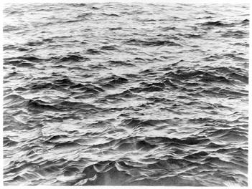 | - Hue, tint, tone, shades and mood.  - Explore the use of texture in colour.  - Colour for purposes.  - Colour to express feelings.  Artist Link - Fischli and Weiss  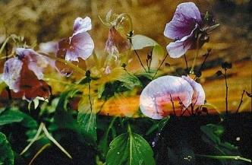 | - Builds up drawings and images of whole or parts of items using various techniques  - Screen printing  - Explore printing  - techniques used by various artists  Artist Link – Bridget Riley  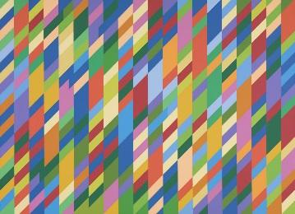 | - Develops experience in embellishing  - Applies knowledge of different techniques to express feelings  - Work collaboratively on a larger scale  Artist Link – Jan Beaney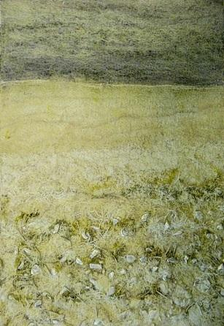 | - Create own abstract pattern to reflect personal experiences and expression.  - Create pattern for purposes.  Artist Link - Beatriz Milhazes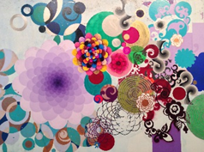 | - Plan and develop ideas  - Shape, form, model and join  - Observation or imagination  - Properties of media  - Discuss and evaluate own work and that of other sculptors  Artist Link – Barbara Hepworth  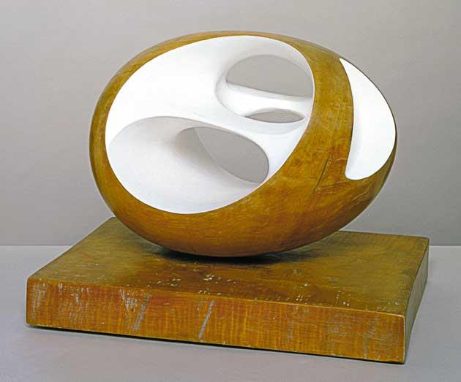
Vocab | As previous year groups, plus…  Chiaroscuro – The contrast of light and dark areas of a drawing or painting  Perspective – The skill of giving an image depth or the impression of three dimensions on a two dimensional surface  Vanishing point – The point of convergence of parallel lines on a 2D plane which gives the impression of depth e.g. train tracks coming together in a drawing. All lines deemed to be parallel in the object, e.g. windows and roof of a house, should meet at a single point on a drawing. | As previous year groups and disciplines, plus…  Aperture – the size of the opening in the lens which lets light in.  Depth of field – The amount of the image which is in focus.  Focus – The part of the image which is sharp at its edges.  Exposure – How light or dark the image is because of how long the aperture remains open.  Layering – The concept of placing one image over another for effect.  Composition - The arrangement of the individual elements within a work of art so as to form a unified whole; also used to refer to a work of art, music, or literature, or its structure or organization.  Abstract – Name given to artwork which does not try to represent reality, but gets its effect from colour, texture and form. | As previous year groups and disciplines, plus…  Work into – The act of developing sections of a print using other artistic techniques e.g. drawing. | As previous year groups and disciplines, plus…  Collaboration – To work with others on a larger goal. In art this could mean creating a section e.g. part of a patchwork quilt. | As previous year groups and disciplines, plus…  Theme - A subject or topic of discourse or of artistic representation. | As previous year groups and disciplines, plus…  Subtractive – Sculpture made by removing materials.  Negative space – The area which is not occupied by the sculture.  Positive space – The area which is occupied by the sculpture.

Alternative artists
Drawing | Painting | Printing | Textiles | Collage/Mixed Media | Sculpture/3D
Joan Miro  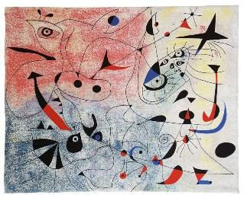  Keith Haring  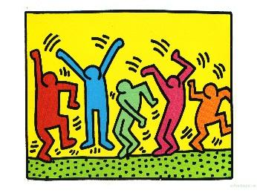 | Jacob Lawrence  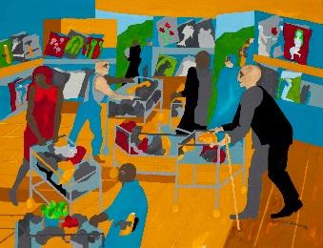  Giotto  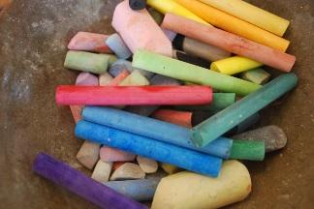  Pablo Picasso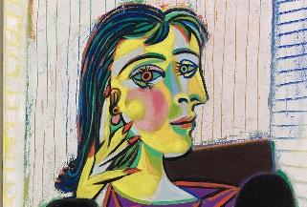  Vincent Van Gogh  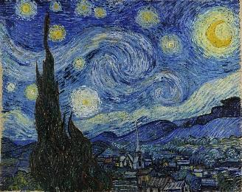  David Hockney  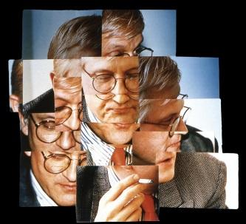 | Georgia O’Keefe  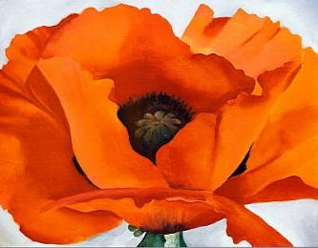  Banksy  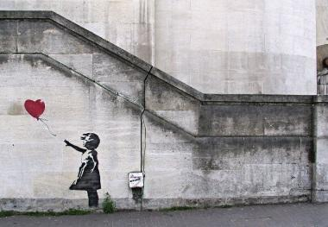 | Faith Ringgold  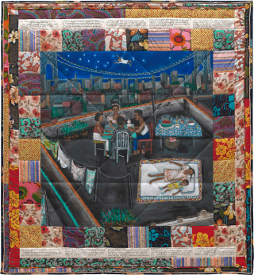 | Aelita Andre  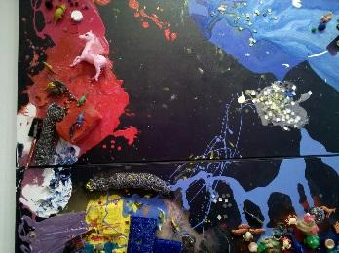  Piet Mondrian  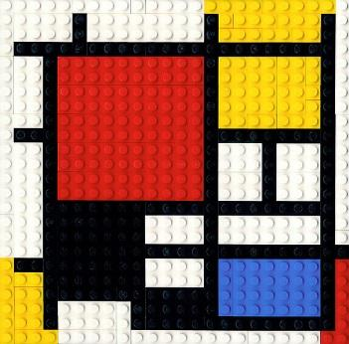

EYFS Whitworth – Nature Play/Light and Dark/Senseshttp://www.whitworth.manchester.ac.uk/learn/schoolscollegesanduniversities/earlyyears/artschool/
Year one Warrington Museum – Ways of looking at art
Year Two Lowry – L.S. Lowry
Year Three http://www.phm.org.uk/programme/participate-print-power/
Year Four Whitworth – Textiles (Make)
Year Five Tate – Roy Lichtenstein
Year Six Walker – Draw to explore orhttp://www.phm.org.uk/programme/participate-drawing-on-manchester/

