Playtime Granola Bars

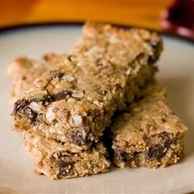

Ingredients

- 2 cups rolled oats
- 3/4 cup packed brown sugar
- 1/2 cup wheat germ
- 3/4 teaspoon ground cinnamon
- 1 cup all-purpose flour
- 3/4 teaspoon salt
- 1/2 cup honey
- 1 egg, beaten
- 1/2 cup vegetable oil
- 2 teaspoons vanilla extract
- 3/4 cup raisins
Method

- Preheat the oven to 350 degrees F (175 degrees C). Generously grease a 9x13 inch baking pan.
- In a large bowl, mix together the oats, brown sugar, wheat germ, cinnamon, flour, raisins and salt. Make a well in the center, and pour in the honey, egg, oil and vanilla. Mix well using your hands. Pat the mixture evenly into the prepared pan.
- Bake for 30 to 35 minutes in the preheated oven, until the bars begin to turn golden at the edges. Cool for 5 minutes, then cut into bars while still warm. Do not allow the bars to cool completely before cutting, or they will be too hard to cut.

