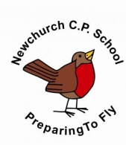
Science Long Term Plan
 | AUTUMN | SPRING | SUMMER
YEAR 1 | Seasonal Changes  Materials | Animals, including humans  Seasonal Changes | Plants  Seasonal Changes
YEAR 2 | Animals, including humans  Plants throughout the year | Use of everyday materials  Plants throughout the year | Living things are their habitats  Plants throughout the year
YEAR 3 | Light and Dark  Rocks | Forces: Magnets  Animals, including humans | Plants  Enquiry based theme
YEAR 4 | States of Matter  Electricity | Living things and their habitats  The Water Cycle | Animals, including humans  Sound
YEAR 5 | Living things and their habitats throughout the year  Animals including humans | Earth and Space  Properties of materials | Changes in materials  Forces
YEAR 6 | Light  Electricity | Evolution  Animals, including humans | Chemistry  Revision: Forces, Space, States of Matter, Rocks and Minerals and Sound

