SHARE IN OUR LEARNING: Year 2 Autumn A
English | We are looking traditional tales and fairy tales with a view to re-telling and re-writing the tales with a twist. This may be changing characters in the story or setting from that of the traditional tale.
Mathematics  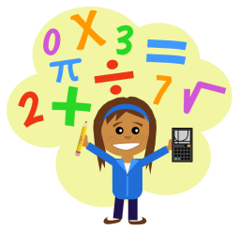 | We will be looking at place value, which will involve, counting in 2s, 5s and 10s forwards and backwards. Understanding the value of a digit in a number ( tens and units) and learning the signs for greater than, less than and equal to < > = and using these to compare values of numbers
Science  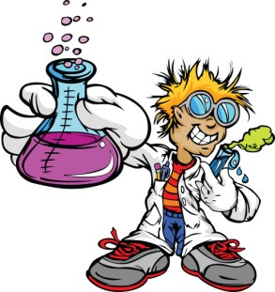 | Our Science topic this term is ‘Animals including Humans’. The children will be looking at if animals are born from an egg or born live and how they change as they grow and what category an animal fits into and its features, e.g. mammals, amphibians, fish etc. We will be learning about the life cycle of animals and humans and the children will be creating their own animal lifecycle for the animals we learn about. We will also be learning what we need to grow and keep healthy, including designing their own healthy balanced menu.
Topic | Our topic this term is Geography and is based on the book ‘The Queen’s Handbag’. We will use this to gather information about the 4 countries in the UK and looking at landmarks and create their own journeys for the Queen’s handbag as it travels through the UK. We will also link this to our computing topic and look at webcams in different places in the UK and compare this to the local community to see how places are different.
PE  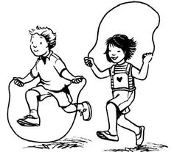 | IN PE our topic is gymnastics. We will be developing our balancing skills, balancing on body parts demonstrating tension and stillness. We will be working with partners to create different ways to travel high and low and through spaces which will enable us to travel over, under and through different pieces of apparatus.
Other  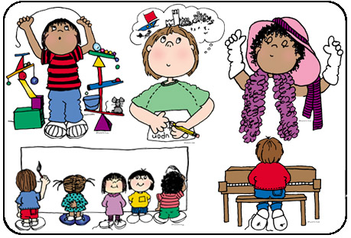 | In Music we are learning to play the hand bells.  Computing – using Skype and Facetime  RE – Christianity: What stories are told about God? Why are they told?  Art – Drawing  PSHE- respect

