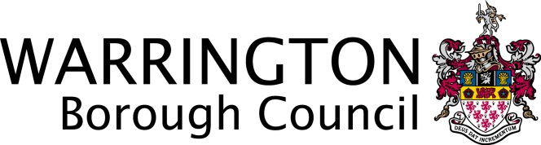
Professor Steven Broomhead
Chief Executive

Steve Reddy
Executive Director
Families and Wellbeing

Sarah Callaghan (Deputy DCS)
Operational Director
Universal Services

New Town House
Buttermarket Street
Warrington
WA1 2NH

January 2016

Dear Parents and Carers

As you are aware, access to and use of social media is common these days and has become second nature to many of us. With this in mind, we wanted to provide some advice that is intended to help safeguard your children and yourselves as parents/carers.

Social media is a good example of how online behaviour can present e-safety risks. Users can express themselves with online personalities and chat and socialise with peers. They can publish and share multimedia content such as music, photos and video clips. If used inappropriately however, users can put themselves and others at risk.

Most social media sites set age restrictions. Facebook, for example, sets an age restriction of 13 years of age for users of its site. However, there is no verification and younger children often ignore the terms and conditions of use, unaware of the risks this might pose. Something to remember is that if your child is using false information to obtain an account on a social media site, other people can do so as well.

Most social media sites allow users to set their profiles to ‘private’ for viewing only by approved contacts. By not using these settings, users can put themselves at risk.
Children and young people can also put themselves, and others, at risk when they:

- Upload inappropriate, offensive or even illegal content to their own online spaces;
- Post material that could damage their reputation or the reputation of others;
- Post inappropriate comments on other people’s profiles that is humiliating or results in bullying;
- Accept friend requests or engage in chat with people who they do not know.

Unfortunately, some parents and carers can also put themselves at risk when posting online about incidents that may have taken place at school. Cases of inappropriate comments to and about others, inaccuracies and misrepresentation are now commonly reported in the media and will be taken seriously by the school. Comments made online are not safe and secure and should never be considered as such. We need to set the best example for our children, so we would urge you to think before you type/post and also consider the school’s home-school agreement.

If you, as parents and carers have any concerns about matters taking place at school, please address them through the appropriate channels, i.e. a discussion with the class teacher or head teacher, rather than expressing your concerns online. In this way, your school can work with you to address any concerns that you may have.

Violence or threat of violence expressed online is completely unacceptable and potentially criminal. ‘Cyber bullying’ is not a matter the Local Authority or our schools take lightly.

If you have any concerns about your child’s use of social networking sites or would like support in knowing how to keep your child safe online please contact your school for advice, support and signposting. Alternatively you can access information via www.thinkuknow.co.uk

Your school has a social media policy, or equivalent, and they will be happy to provide you with a copy if you wish.

Yours sincerely

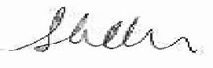

Sarah Callaghan
Operational Director Universal Services

Direct dial: 01925 442937
Email: scallaghan@warrington.gov.uk

