SHARE IN OUR LEARNING: Year 6 Autumn A
English  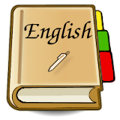 | Writing  Mystery and suspense  - investigating narrative structures  - developing use of ambitious vocabulary  Grammar and punctuation  - understanding the use of parenthesis  - developing use of colon and semicolon  - using accurate speech punctuation  Reading  Kit’s Wilderness  - author’s use of vocabulary  - characterisation and developing settings
Mathematics  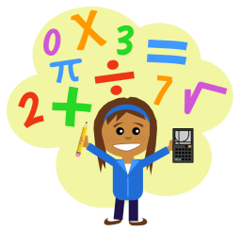 | Four operations  - using formal written methods for +, -, x and ÷  - problem solving using the four operations  Fractions  - use arithmetic methods to add, subtract, multiply and divide fractions  - recognise fractions of whole numbers and decimals  - recognise the link between decimals, fractions and percentages  Ratio and proportion  - identify the relative size of quantities  - solve problems with unequal sharing
Science | Light  - recognise that light appears to travel in straight lines  - use the idea that light travels in straight lines to explain that objects are seen because they give out or reflect light into the eye  - explain that we see things because light travels from light sources to our eyes or from light sources to objects and then to our eyes  - use the idea that light travels in straight lines to explain why shadows have the same shape as the objects that cast them.
Topic | Crime and Punishment - a study of an aspect or theme in British history that extends pupils’ chronological knowledge beyond 1066.  - understand and explain how changes happen over time  - offer opinion using evidence to support ideas  - organise historical events and information  - begin to understand causal factors in change
PE  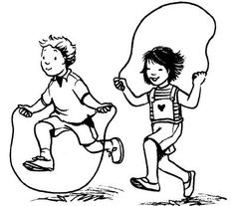 | Ball handling skills and Cognition  - Benchball and Throw Tennis  - Considering how to evaluate and improve performance through self- and peer-assessment  - Recognises how to develop tactics  - Understanding rules
Other  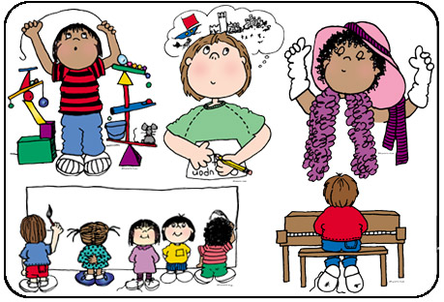 | - RE (Christianity) - Is life like a journey? What do we commit ourselves to on our journey?  - Music – Brass  - Computing – Spreadsheets  - PSHE – Respect and our personal values  - British Values – Are we really free? Cultural similarities and differences – celebrating diversity  - Art - Drawing

