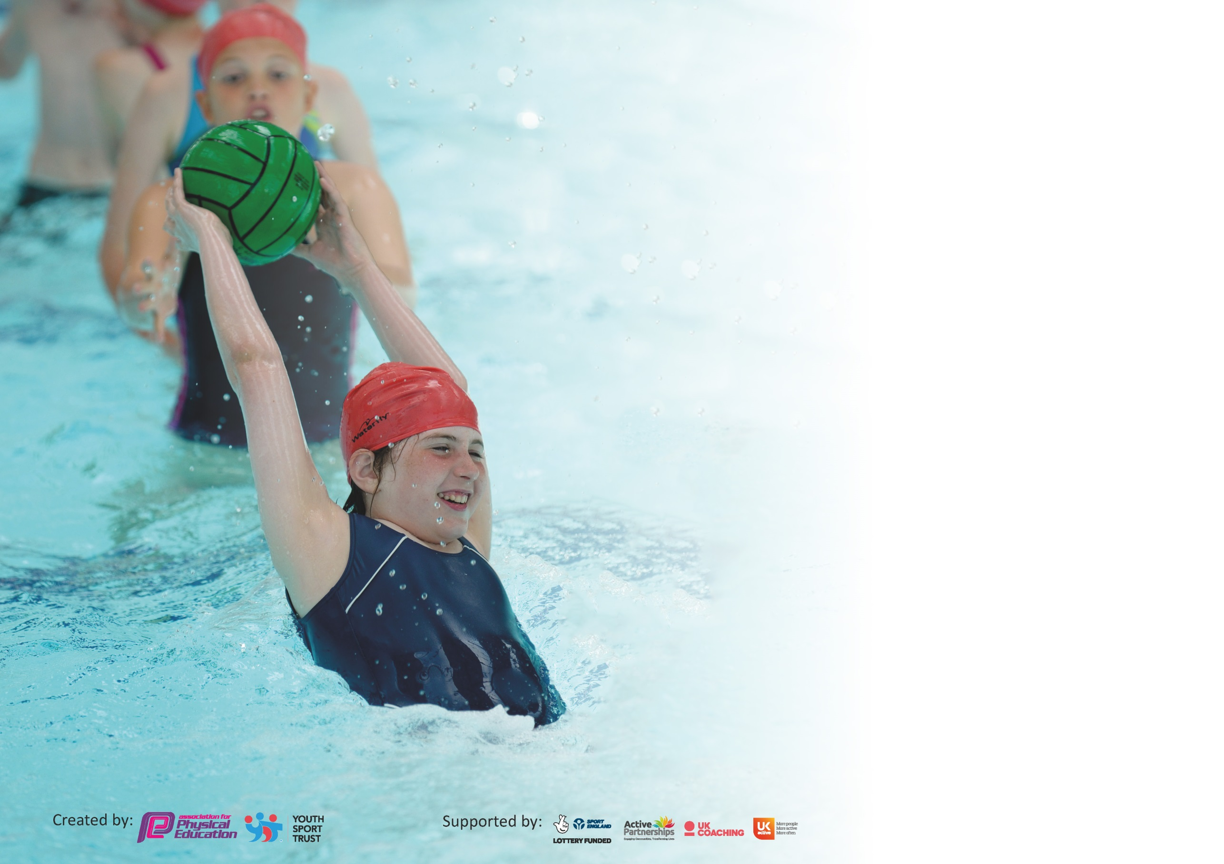

It is important that your grant is used effectively and based on school need. The Education Inspection Framework (Ofsted 2019 p64) makes clear there will be a focus on ‘whether leaders and those responsible for governors all understand their respective roles and perform these in a way that enhances the effectiveness of the school’.

Under the Quality of Education criteria (p41) inspectors consider the extent to which schools can articulate their curriculum (INTENT), construct their curriculum (IMPLEMENTATION) and demonstrate the outcomes which result (IMPACT).

To assist schools with common transferable language this template has been developed to utilise the same three headings which should make your plans easily transferable between working documents.

Schools must use the funding to make additional and sustainable improvements to the quality of Physical Education, School Sport and Physical Activity (PESSPA) they offer. This means that you should
use the Primary PE and Sport Premium to:

- Develop or add to the PESSPA activities that your school already offer
- Build capacity and capability within the school to ensure that improvements made now will benefit pupils joining the school in future years

Please visit gov.uk for the revised DfE guidance including the 5 key indicators across which schools should demonstrate an improvement. This document will help you to review your provision and to report your spend. DfE encourages schools to use this template as an effective way of meeting the reporting requirements of the Primary PE and Sport Premium.

We recommend you start by reflecting on the impact of current provision and reviewing the previous spend.

Schools are required to publish details of how they spend this funding as well as on the impact it has on pupils’ PE and sport participation and attainment by the end of the summer term or by 31st July 2020 at the latest.

We recommend regularly updating the table and publishing it on your website throughout the year. This evidences your ongoing self-evaluation of how you are using the funding to secure maximum, sustainable impact. Final copy must be posted on your website by the end of the academic year and no later than the 31st July 2020. To see an example of how to complete the table please click HERE.

Support for review and reflection - considering the 5 key indicators from DfE, what development needs are a priority for your setting and your pupils now and why? Use the space below to reflect on previous spend and key achievements and areas for development.

Key achievements to date until July 2020: | Areas for further improvement and baseline evidence of need:
Autumn Term  Brought in Commando Joe, an external provider to help develop our PE curriculum for outdoor learning  PE apprentice appointed and is being supported by teaching staff to develop his understanding of the teaching of PE.  Competitive sports already begun are on target to achieve 100% of KS2 children being given the opportunity to represent school in inter-school sports competitions this academic year.  Numbers of children being active at lunch times is on the rise.  Year 3 and Year 4 taking part in swimming lessons.  Spring Term  Increased number of extra-curricular clubs to the greatest number we have ever had. These include two football clubs, Change 4 Life (run by Sports Leaders), rugby, multi-sports, hockey, dodgeball and dance  Use of new equipment has continued to engage chn in lunchtime activities  ‘March Madness’ event has given all chn the opportunity to participate in intra-school competitions. Throughout the month, we ran 3 intra-school events before lockdown with 1 more being cancelled.  A number of inter-school events were booked in the diary but were unable to take place due to lockdown.  Awarded School Games Gold Mark  Summer Term  Inclusive Virtual Sports Day for children to allow participation from home. | Autumn Term  Promote awareness of PE around the school with bulletin boards to show everyone what is happening.  Continue to train Sports Leaders to give them all the tools required to run a Change 4 Life Club  Gradually increase the percentage of time our PE apprentice is spending delivering lessons.  Spring Term  Organise intra-school events for the Summer term. Include Y6 chn to help develop sports-leaders and begin to identify chn who wish to be Sports Leaders for the following academic year.  Develop new ways to show how children have made progress through their PE lessons.  Summer Term/Following Academic Year  Continue to provide a range of extra-curricular activities  Develop Forest Schools activities to help promote outdoor learning in PE to replace Commando Joe  Liaise with Livewire aquatics to seek opportunities for additional swimming lessons in Y5/6 for those who didn’t pass their N/C swimming qualification

Meeting national curriculum requirements for swimming and water safety.
What percentage of your current Year 6 cohort swim competently, confidently and proficiently over a distance of at least 25 metres?  N.B. Even though your pupils may swim in another year please report on their attainment on leaving  primary school at the end of the summer term 2020. | 72%
What percentage of your current Year 6 cohort use a range of strokes effectively [for example, front crawl, backstroke and breaststroke]? | 38%
What percentage of your current Year 6 cohort perform safe self-rescue in different water-based situations? | 72%
Schools can choose to use the Primary PE and Sport Premium to provide additional provision for swimming but this must be for activity over and above the national curriculum requirements. Have you used it in this way? | Yes/No

Action Plan and Budget Tracking
Capture your intended annual spend against the 5 key indicators. Clarify the success criteria and evidence of impact that you intend to measure to evaluate for pupils today and for the future.

Academic Year: 2019/20 | Total fund allocated: £17830 | Date Updated: 20/07/20
Key indicator 1: The engagement of all pupils in regular physical activity – Chief Medical Officer guidelines recommend that primary school pupils undertake at least 30 minutes of physical activity a day in school |  |  |  | Percentage of total allocation:
 |  |  |  | 12%
Intent | Implementation |  | Impact
Your school focus should be clear what you want the pupils to know and be able to do and about  what they need to learn and to  consolidate through practice: | Make sure your actions to achieve are linked to your intentions: | Funding allocated: | Evidence of impact: what do pupils now know and what can they now do? What has changed?: | Sustainability and suggested next steps:
Provide a wide range of competitive sports opportunities for all of our KS2 pupils  Improve quality of sporting/games activities at lunchtimes with quality leadership and improved equipment. | Bought into the Warrington School Sports Partnership. This allows our children to participate in vast amounts of inter-school competition as well as hire a wide range of specialised sports equipment to give children a greater range of activities to immerse themselves in.  Ensure regular communication with the WaSSP to keep changing the hired equipment. PE Coordinator to ensure competitions are being booked for children to have opportunities to compete against other schools.  Equipment such as skipping ropes, balls, bats, chalks to be purchased. Work with MDA’s to develop a register system to record children who are/aren’t participating. | £1700  £400 | New and hired equipment from WaSSP is being used regularly at lunchtimes. Children have enjoyed the opportunity to use archery sets, skipping ropes, speed stack, rowing machines, badminton and fencing equipment this academic year.  MDA’s report a large increase in physical activity at lunchtimes due to enthusiasm for equipment.  100% of KS2 children have had the opportunity to participate in both inter and intra-school competitions this year.  Children have such a wealth of equipment at their disposal that we have seen great levels of engagement in sports and games at lunchtimes. PE apprentice has been integral in organizing games and intra-school competitions to allow all children to participate. Medals, trophies and certificates were purchased to give a physical reward for participation. | Continue to provide new and engaging sporting opportunities. Generate register system to gather data on numbers of chn.  To increase our contacts with external clubs who can provide children with meaningful, long-lasting links with particular sports of interest. E.g. running clubs, rowing clubs etc.  Continue to monitor the quality of PE equipment. Audit PE equipment, especially perishables such as chalks to ensure that there is always sufficient supply for demand. Look at ways of linking dance into lunchtimes through discos.
Key indicator 2: The profile of PESSPA being raised across the school as a tool for whole school improvement |  |  |  | Percentage of total allocation:
 |  |  |  | 15%
Intent | Implementation |  | Impact
Your school focus should be clear what you want the pupils to know and be able to do and about  what they need to learn and to  consolidate through practice: | Make sure your actions to achieve are linked to your intentions: | Funding allocated: | Evidence of impact: what do pupils now know and what can they now do? What has changed?: | Sustainability and suggested next steps:
To raise the profile of PE and Sports engagement across the school to ensure that the emphasis on the importance of sports at our school is evident for all to see.  Celebrate chn’s sporting successes with a celebrations on the school social media pages and on the school newsletter. Marquee events to be celebrated in local news outlets. | To lead on all aspects of the PE curriculum as shown within this document.  To be accountable for the spending of the PE and sport Premium.  Create new and exciting opportunities for each class.  Ensure system focuses on those chn who are least active to encourage them to want to increase participation.  Communicate events effectively with parents and children  Champions to attend training days with PE lead to develop their skills and confidence. | £2757 | Greater numbers of chn wishing to take part in events. Chn also really keen to show off their achievements from their external clubs such as swimming, dance, gymnastics and golf.  Y6 Sports Leaders are running the Active Lifestyles club themselves with LS overseeing and providing feedback to them for future sessions.  Sports Leaders have been trained by PE lead to set up and run the C4L club under his supervision. They have also participated in Sports Leaders Camps with the Warrington School Sports Partnership. Their enthusiasm for generating new ideas and involving all chn (particularly the younger learners) has been a huge success. | Continue to train leaders so that they are confident at running lunchtime club too to increase participation opportunities.  Arrange opportunities for professionals to come to school and lead on areas in physical education and mental wellbeing.  Look for opportunities to engage the community in events and competitions

Key indicator 3: Increased confidence, knowledge and skills of all staff in teaching PE and sport |  |  |  | Percentage of total allocation:
 |  |  |  | 38%
Intent | Implementation |  | Impact
Your school focus should be clear | Make sure your actions to | Funding | Evidence of impact: what do | Sustainability and suggested
what you want the pupils to know | achieve are linked to your | allocated: | pupils now know and what | next steps:
and be able to do and about | intentions: |  | can they now do? What has
what they need to learn and to |  |  | changed?:
consolidate through practice:
To utilise the strengths of our teachers when delivering PE to provide opportunities for a PE apprentice.  Continue to develop the knowledge of staff through training and CPD. | Quality of PE teaching has increased considerably over the past few years and we are in a position to utilise our strengths to support a PE apprentice and further enhance our PE team and provision.  To support a PE apprentice through a year’s on-the-job training.  To educate the apprentice to be competent at delivering PE lessons  To utilize the expertise of staff to allow for the apprentice to see a range of teaching strategies.  Apprentice to understand the importance of inclusion in PE, ensuring that he caters for all levels of ability.  Apprentice to understand the significance of competition and support the PE coordinator in organizing School Games competitions.  Continue to develop the expertise of teaching PE. Learning walk in Autumn term for base lining and then ongoing throughout the year. Provide training for staff to develop teaching. Look for specific CPD for any areas of development. Repeat learning walk in Summer term to see impact of training.  Ensuring coverage of all areas of PE. Teachers to provide a yearly guide of the PE curriculum they are teaching with an expectation of 2 hours per week. Overview of coverage and sports this is being covered linked closely to the National Curriculum guidance and Programmes of Study. | £6860 | The PE apprentice has made excellent progress over the course of the year. From observing lessons and identifying what a good PE lesson looks like, he was able to start contributing to elements of the PE lesson in small groups. The apprentice showed great competency for this and an eagerness to progress further. As we come to the end of the academic year, he is now, with support of the class teacher, leading PE lessons and delivering sessions which cater for all learners, shows challenge, is pitched correctly and has all children motivated and wanting to achieve.  The apprentice has an excellent rapport with both staff and pupils and has managed behavior really well.  Beyond the PE lesson, the apprentice has led many extra-curricular clubs which include football, rugby, Dodgeball, netball, multi-sports, archery and hockey. He has also been instrumental in organizing intra-school competitions at lunchtimes which have given the children opportunities to remain active, be competitive and has provided PE with a bigger platform at the school.  Staff from each key stage have been on a dance training course to help support their teaching practice. Staff have fed back to colleagues to help share good practice. | Continue to keep staff updated on latest PE developments.  Look for opportunities to train staff in mental wellbeing and PE. After the Covid19 pandemic, children may find PE to be a useful resource in promoting their mental wellbeing. We will make sure we are prepared for this.
Key indicator 4: Broader experience of a range of sports and activities offered to all pupils |  |  |  | Percentage of total allocation:
 |  |  |  | 34%
Intent | Implementation |  | Impact
Your school focus should be clear | Make sure your actions to | Funding | Evidence of impact: what do | Sustainability and suggested
what you want the pupils to know | achieve are linked to your | allocated: | pupils now know and what | next steps:
and be able to do and about | intentions: |  | can they now do? What has
what they need to learn and to |  |  | changed?:
consolidate through practice:

To increase participation in extracurricular sports to at least 50% of KS2 children.  Provide a wider range of after school sports clubs  Develop the problem solving skills, critical thinking and resilience of the children. | To work with the MDA’s and apprentice to set up a lunchtime sports club.  Set up and run a Change 4 Life club to encourage participation of the ‘least active’ population.  Utilise the skills of school staff to give a broader range of activities.  .  Warrington Wolves coaching for all children from reception to Y6 inc. after school club.  Buy into the Commando Joe’s programme for whole school  Dance Club performed at a large venue | £500  £5610 | Over 70% of our KS2 children have participated in extra-curricular club either before school, at lunch time or after school. As above, numbers participating in lunchtime activities has increased considerably due to the draw of the PE apprentice and the new equipment.  C4L successfully continuing with high demand for the club.  Tennis and Warrington Wolves clubs are currently in process.  Chn have enrolled to external clubs based on their experiences of the clubs provided in school.  Children from Y2 to Y6 have had a weekly hour slot provided by the external provider. The sessions have a military theme to them with a hook from famous explorers such as Ed Stafford. The sessions have allowed children to work in teams to solve problems, to identify that they may need to get things wrong at first to identify how to come at problems from a different perspective and challenge each other to problem solving too. | Continue to provide a wide array of opportunities for the children.  Enquiries made for future clubs to become available with a focus on clubs which promote mindfulness and wellbeing. Explore opportunity of yoga/meditation sessions to begin before school. Targeted initially at PP chn and those who require additional support for mental wellbeing and mindfulness  To liaise with staff regarding the impact of the programme with each of their classes and identify whether we should continue to use the provider, utilize the strengths of our own staff or seek an alternative provider.

Key indicator 5: Increased participation in competitive sport |  |  |  | Percentage of total allocation:
 |  |  |  | %
Intent | Implementation |  | Impact
Your school focus should be clear | Make sure your actions to | Funding | Evidence of impact: what do | Sustainability and suggested
what you want the pupils to know | achieve are linked to your | allocated: | pupils now know and what | next steps:
and be able to do and about | intentions: |  | can they now do? What has
what they need to learn and to |  |  | changed?:
consolidate through practice:
To provide our children with extensive opportunities to participate in a range of intra-school and inter-school competitions | Bought into the Warrington School Sports Partnership. They organise and run hundreds of level 1 and level 2 tournaments across the borough. Through this, we will ensure that all of our KS2 children have been given the opportunity to participate in a competitive sporting event.  The Partnership also provides an equipment-loan system which we will utilise to allow children greater sporting opportunities within school.  Created a number of intra-school competitions to allow all of our children to participate in exciting and engaging sports events  Aim to provide inter-school and intra-school opportunities for every child in KS2  Develop competition across the school and within the school  J Join Warrington Schools Football League to ensure increased participation.  Participation in the annual Warrington Wolves Tag Rugby Festival for Year 3/4 (cancelled due to lockdown) | £0 (costed in Key Indicator 1) | New and hired equipment from WaSSP is being used regularly at lunchtimes. Children have enjoyed the opportunity to use archery sets, skipping ropes, speed stack, rowing machines, badminton and fencing equipment this academic year.  Midday assistants report excellent engagement in physical activity at lunchtimes due to enthusiasm for equipment.  Children have such a wealth of equipment at their disposal that we have seen great levels of engagement in sports and games at lunchtimes. PE apprentice has been integral in organizing games and intra-school competitions to allow all children to participate. Medals, trophies and certificates were purchased to give a physical reward for participation. | Continue to provide new and engaging sporting opportunities. Generate register system to gather data on numbers of children.  To increase our contacts with external clubs who can provide children with meaningful, long-lasting links with particular sports of interest. E.g. running clubs, rowing clubs etc.  Continue to monitor the quality of PE equipment. Audit PE equipment, especially perishables such as chalks to ensure that there is always sufficient supply for demand. Look at ways of linking dance into lunchtimes through discos.

Signed off by
Head Teacher:
Date:
Subject Leader:
Date:
Governor:
Date:

