SHARE IN OUR LEARNING: Year 1 Autumn A
English  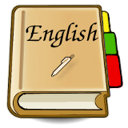 | Reading:  - Reading words containing Phase 3 Graphemes  - Reading Phase 2, 3 and Phase 4 tricky words  - Reading CVCC and CCVC words e.g. tent, train, steep and longer compound and 2 syllable words  - Learning new Phase 5 sounds and tricky words  Writing  - Spelling tricky words accurately (Phase 2-4)  - Orally segmenting to spell unfamiliar words  - Using phonics knowledge to make phonetically plausible attempts at unfamiliar words  - Forming caterpillar letters accurately  - Using a capital letter at the start of a sentence and full stop at the end.
Mathematics  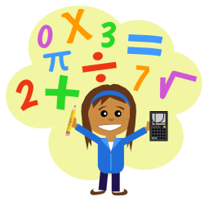 | Number: Place Value  - Count to ten, forwards and backwards, beginning with 0 or 1, or from any given number.  - Count, read and write numbers to 10 in numerals and words.  - Identify and represent numbers using objects and pictorial representations including the number line, and use the language of: equal to, more than, less than (fewer), most, least.  - Given a number, identify one more or one less.  - Count in multiples of twos.  Number: Addition and Subtraction  - Represent and use number bonds and related subtraction facts (within 10)  - Add and subtract one digit numbers (to 10), including zero.  - Read, write and interpret mathematical statements involving addition (+), subtraction (-) and equals (=) signs.  - Solve one step problems that involve addition and subtraction, using concrete objects and pictorial representations and missing number problems.
Science | Seasonal Changes  - Observing changes in the seasons  - Observing and describing weather associated with the seasons and how day length varies
Topic | You, Me and Newchurch  - Using simple compass directions (N, E, S, W) and locational and directional language [for example, near and far; left and right], to describe the location of features and routes on a map.  - Recognising key human features, including: city, town, village, factory, farm, house, office, port, harbour and shop  - Using aerial photographs and plan perspectives to recognise landmarks and basic human and physical features; devising a simple map; and use and construct basic symbols in a key  - Using simple fieldwork and observational skills to study the geography of our school and its grounds and the key human and physical features of its surrounding environment.
PE  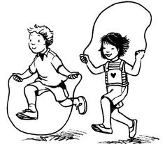 | Personal Skills:  - I ask for help when appropriate  - I can work on simple tasks by myself  - I can follow instructions and practise safely  Physical Skills:  - Coordination – moving in different ways e.g. hopping, skipping, hop-scotch, galloping, side stepping, to create floor patterns  - Balance – performing static balance on 1 leg consistently and confidently, holding for 10 seconds.
Other  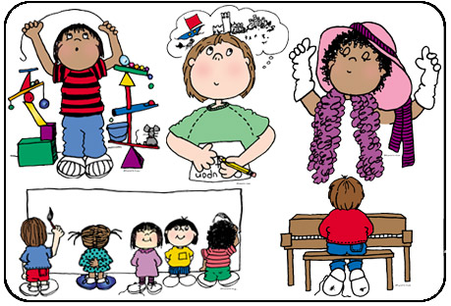 | - RE (Christianity) – What do some people do because they believe in God?  - Computing – manipulating images – collecting images using collage apps linked to their learning then adding text to support images  - Art – Drawing linked to our learning in science and geography  - PSHE – Respect

