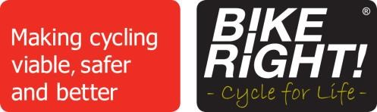
Dear Parents/Carers,

BikeRight! will soon be coming to your child’s school to run a Bikeability course which your child has the opportunity to take part in. Listed below are details of the course and what your child will need to be able to take part.

YEAR 6 WEEK COMMENCING 16TH NOVEMBER 2020

What is Bikeability?
Bikeability is the new Cycling Proficiency for the 21st century. It’s designed to give the next generation the skills and confidence to ride their bikes on today's roads. We will teach children to ride a bike to National Standards and introduce them to cycling as an everyday, fun, healthy activity and an alternative mode of transport.

How much will it cost?
Nothing! The course is funded by your Local Authority and Department for Transport grants.

Where will the course take place?
The course will take place in the school playground and on local roads near to the school. We will carry out a risk assessment of the training areas before the start of the course. A copy of the risk assessment will be available at the school.

What will my child need?
- The ability to ride a bike unaided.
- A signed consent form – please use the form on the next page.
- A Helmet
- Appropriate clothing. It is important, especially during the cooler months, that children wear gloves and warm, dry clothing as they will be outside all day.
- A bike which is road worthy. Please follow the simple guide below to check whether your child’s bike is suitable.
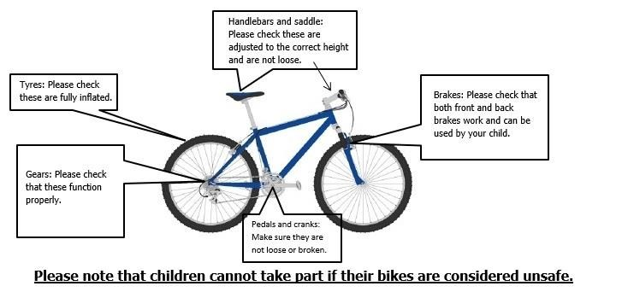

BikeRight!
The Boat Shed, Building 4 Office 1, 22 Exchange Quay, Salford M5 3EQ
Tel: 0161 230 7007 info@bikeright.co.uk www.bikeright.co.uk @bikerightUK facebook.com/bikeright
BikeRight! is a limited company registered in England and Wales. Registered number: 5742951. Registered office: Cuthbert Business Centre, 877 Ashton Old Road, Manchester, M11 2NA.

BikeRight! Bikeability Consent Form Please complete and return to school by the above date

Rider Full Name
Age |  | Year Group |  | Gender
Any special needs or medical conditions

TERMS & CONDITIONS FOR SCHOOL CYCLE TRAINING
Parent / Carer please read carefully. If you agree, please sign the consent form.

- This consent form MUST be signed by the child’s parent / carer.
- All trainees MUST wear an approved cycle helmet while undertaking the training and the supplied high-visibility waistcoat.
- The instructor will determine if the trainee is able to control their bicycle sufficiently well to take part in the training.
- Training takes place initially in the school playground. If the trainees have reached the required standard, they will then be taken out onto local roads for further on road training.
- Training will cover all aspects of safer cycling, including recommended procedures for starting, stopping, turning left and right, developing skills and basic strategies for dealing with traffic.
- I agree that the instructor(s) can adjust my child’s bicycle if necessary.
- I am responsible for providing my child with suitable clothing for cycling.
- I confirm that neither my child nor any member of my household has symptoms of COVID-19 or should be self-isolating under government guidelines
- I agree that my child will always adhere to the protective measures set out for education settings under government guidelines, except in case of emergency
- I will contact BikeRight! if my child develops any symptoms of COVID-19 within 48 hours of the training session.

I have read, understood and agree to the Terms and Conditions above
Name |  | Contact Number(s)
Signature |  | Date

To find out more about Bikeability: https://bikeability.org.uk/participants-hub/

BikeRight!
The Boat Shed, Building 4 Office 1, 22 Exchange Quay, Salford M5 3EQ
Tel: 0161 230 7007 info@bikeright.co.uk www.bikeright.co.uk @bikerightUK facebook.com/bikeright
BikeRight! is a limited company registered in England and Wales. Registered number: 5742951. Registered office: Cuthbert Business Centre, 877 Ashton Old Road, Manchester, M11 2NA.

