SHARE IN OUR LEARNING: Year 1 Autumn B
English | Reading:  - Reading words containing Phase 3 and 5 Graphemes  - Reading 3, 4 and Phase 5 tricky words  - Reading CVCC and CCVC words e.g. tent, train, steep and longer compound and 2 syllable words  - Learning new Phase 5 sounds and tricky words  Writing  - Spelling tricky words accurately (Phase 2-4)  - Orally segmenting to spell unfamiliar words  - Using phonics knowledge to make phonetically plausible attempts at unfamiliar words  - Forming ladder letters, caterpillar letters and robot letters accurately  - Using a capital letter at the start of a sentence and full stop at the end
Mathematics | Number and Place value  - To count to and across 100, forwards and backwards, beginning with 0 or 1, or from any given number.  - To count, read and write numbers to 100 in numerals, count in multiples of twos, fives and tens.  - To read and write numbers from 1 to 20 in numerals and words.  - When given a number, identify one more and one less.  Addition and Subtraction  - To represent and use number bonds and related subtraction facts within 20.  - To add and subtract one-digit and two-digit numbers to 20, including zero.  Measures  To compare, describe and solve practical problems for:  - lengths and heights (long/short, longer/shorter, tall/short, double/half)  - mass or weight (heavy/light, heavier than, lighter than)  - capacity/volume (full/empty, more than, less than, quarter)  - time (quicker, slower, earlier, later).  Shape  To recognise and name common 2D and 3D shapes, including:  - 2D shapes (rectangles (including squares), circles and triangles)  - 3D shapes (cuboids (including cubes), pyramids and spheres).
Science | Weather and Seasonal Changes  - Observing changes in the seasons  - Observing and describing weather associated with the seasons and how day length varies  - Working scientifically to gather data on the weather e.g. wind direction, rainfall, temperature
Topic | Disaster on Pudding Lane!  - Explore events beyond living memory that are significant nationally – The great fire of London 1066  - Develop an awareness of the past, using common words and phrases relating to the passing of time  - Know where the people and events fit within a chronological framework  - Identify similarities and differences between ways of life in different periods – houses, fire-fighters  - Use a wide vocabulary of everyday historical terms  - Ask and answer questions, choosing and using parts of stories and other sources to show that they know and understand key features of events  - Understand some of the ways in which we find out about the past and identify different ways in which it is represented.
PE  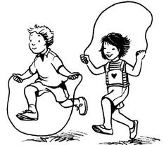 | Social Skills:  - Can I work sensibly with others?  - Can I take turns and share?  - Can I praise others?  Physical Skills:  - Dynamic balance: Jump 2 feet to 2 feet, 2 feet to 2 feet with a quarter turn, tucked jump  - Static balance: Seated balance with no hands or feet, seated balance passing object side to side, seated balance with arms and legs stretched out to form ‘dish’ shape
Other  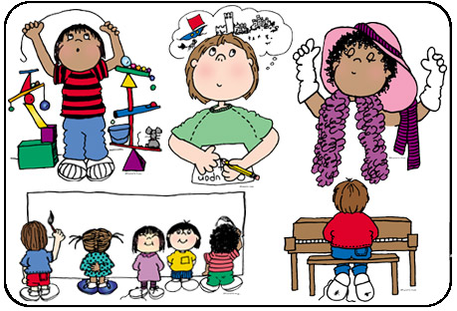 | - RE (Christianity) – What stories are told about God? What do some people do because they believe in God? Exploration of ‘The Christmas Story’ told by Christians.  - Computing – Creating simple computer programmes using block coding on espresso  - Art – Exploring colour mixing using paints, find collections of colour, applying colour with a range of tools and exploring the work of Wassily Kandinsky  - PSHE – Resilience

