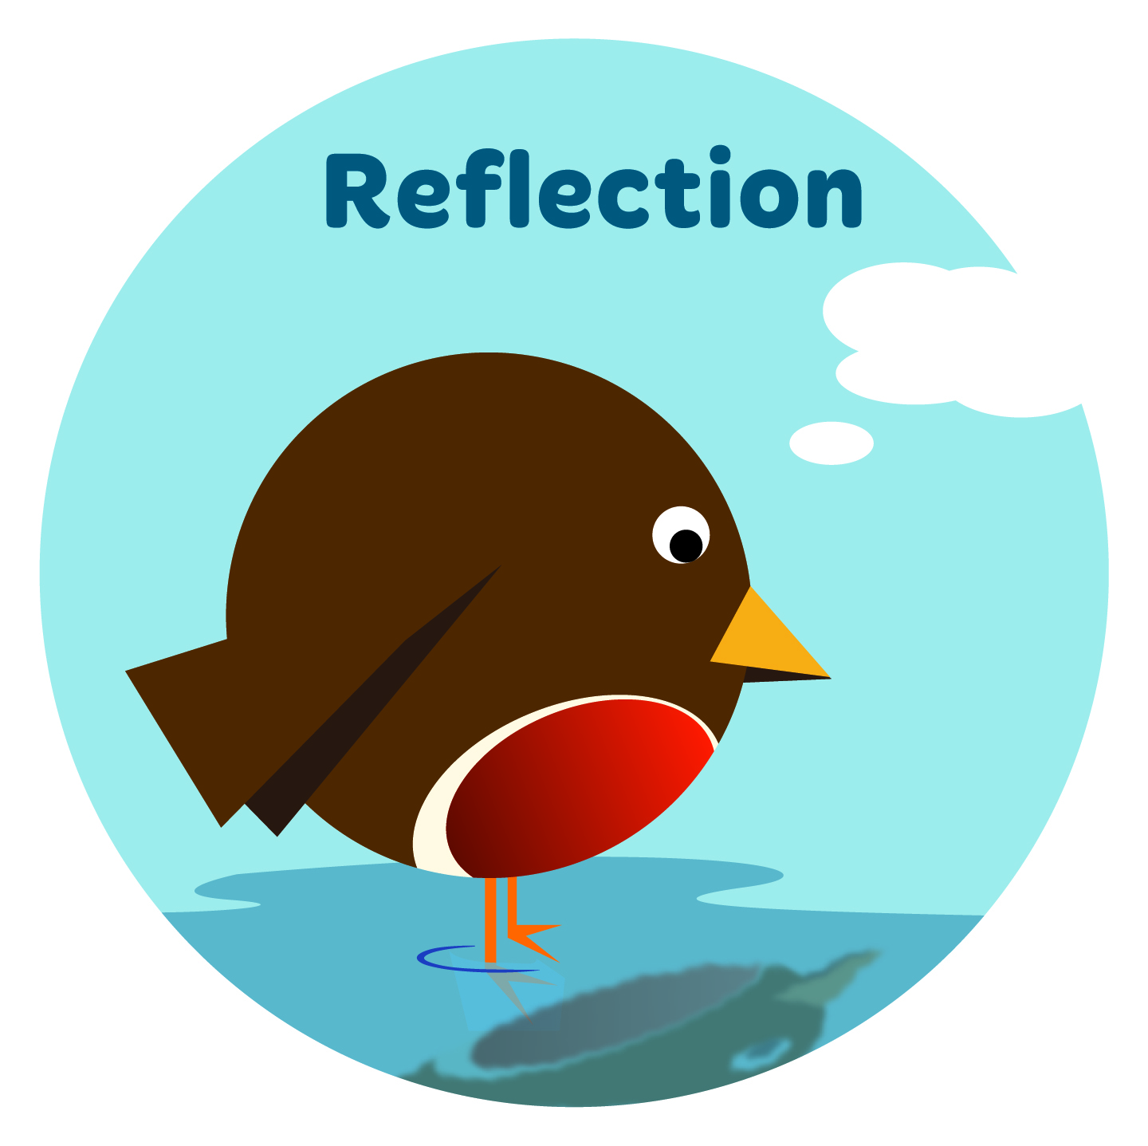
KEY VALUE – REFLECTION – SUMMER 2
FOUNDATION/KEY STAGE 1
Links - key school values: |  | Responsibility, resilience
Associated values: |  | Happiness, humility, love, patience, peace, thoughtfulness, understanding
SMSC criteria: |  | Reflect on their experiences provided by the school, use their imagination and creativity, and develop curiosity in their learning
Cross-curricular links |  | Science
 |  |  | Reception |  | Year 1 |  | Year 2
WEEK | ASSEMBLY  Source materials:  1.The Little Book of Values  2.Developing Spirituality  3. Fables  4.Story books  5.SEAL assembly materials | THEME | THE QUESTIONS CHILDREN ASK! | OUTCOMES | THE QUESTIONS CHILDREN ASK! | OUTCOMES | THE QUESTIONS CHILDREN ASK! | OUTCOMES
1 | Introduction to value - Reflection  What is reflection?  What other values can we think of that are associated with this value?  Why do we need to reflect on issues?  How does reflection help us to understand ourselves and others? | Healthy Lifestyles | Focus - Personal Hygiene  Why do I need to wash?  How often do I need to wash?  What things do I need to keep myself clean? | Know how to keep clean and look after oneself | Focus - Staying Healthy  What makes me healthy, happy and strong?  Why is sport and exercise good for me?  Why do I have to go to bed when I am told even if I don’t feel tired? | Identify the key lifestyle behaviours that contribute to good health | Focus - You are what you eat!  How does our food build our bodies and make us grow?  Which foods give me energy to play?  How does food help us keep healthy and fight disease?  Why can’t I eat lots of biscuits and sweets?  Why do I have to brush my teeth?  Why do I have to go to the dentist? | Understand the need for a varied and balanced diet
2 | Reflecting on and respecting difference and diversity and what makes us unique and special  *Remember you are unique – just like everybody else! | Growing and Changing - Differences | Focus – Baby Boy or Baby Girl  How do I know if a baby is a boy or a girl?  Why are girls’ and boys’ bodies different?  What do we call the different parts of girls’ and boys’ bodies | Know that similarities and differences exist between boys and girls  That sexual organs indicate gender | Focus – We are all unique  What makes me different?  How am I like others? | Appreciate that all humans are unique and special | Focus – Naming Body Parts  Why are the private boy ‘bits’ and girl ‘bits’ different?  What is that ‘bit’ called?  Which parts of my body are private? | Name the agreed terms for the sex organs  Understand that physical differences are vital for reproduction
3 | Reflecting on inter-generational relationships  Respecting experience  Caring for others  Roles and responsibilities  Changing lives – changing needs | Growing and Changing - Lifecycles | Focus – The Needs of a Baby  Who looks after baby?  How does a baby let you know what they want/need?  Why do babies always cry?  What happens at the baby clinic? | Know that babies need someone to care for them to meet their needs | Focus – Animal Lifecycles  Do all animal babies and adults resemble each other?  Do ‘different looking’ babies grow into adults like their parents? | Know that adult animals produce offspring of their own species | Focus –The Human Lifecycle  Where do babies come from?  What did I look like as a baby?  What can I do now that I could not do when I was a baby?  How did I change?  What will I be able to do in the future that I can’t do now?  What are the different needs of people at different stages of their lives? | Understand the changes resulting from age.  Understand the needs of people change as they age
4 | ‘The times – they are a changing’  How change is experienced by everyone  Understanding the different responses to change  Coping with change when we feel uncomfortable | Changes (SEAL) | Focus – How we change overtime 1  How can I help new children to feel happy in our group?  When I notice the way my friends are feeling, what really kind thing can I do for them to change the way they feel?  How can I make myself feel better?  When someone isn’t playing fair how can I let them know how I feel and how we can play better together?  Why do I feel like I do when things change?  How do we know what to do and how to behave? | Name ways in which they have changed during the last year and the way they now deal with situations  Talk about feelings associated with change | Focus – How we change overtime 2  Why are we always changing?  Look how I have grown and changed during my life!  What will I be like in the future?  How much more will I know?  How am I the same?  What has not changed about me?  Why is it important to try hard all the time?  Can someone make you try hard?  Can you always get better or try harder? | Understand that change can be natural and can happen by itself and that it can also be brought about by the individual | Focus – Changing our behaviour  Why do I find it hard to stop behaving in certain ways?  What can I do to change my behaviour and be a better person to others?  How do I make sure that I consider others when I take certain actions?  What makes it hard to change even when we know that it is right?  If something works why would you want to change it?  Is change always good?  How do we know when change is good and when it is bad?  Continue as above | Develop a growing awareness of their personal behaviour and take responsibility for their actions
5 | ‘Always look on the bright side of life!’  Seeing the positive aspects of change  Making it happen  Accept the changes that you can’t control and take charge of those you can. | Changes  (SEAL) | Focus – Dealing with change and making change happen  Why do I feel different at different times of the day?  Sometimes I don’t feel comfortable and I want people to be kind to me – will you be kind to me?  How can I make changes to things that I don’t like or make things better?  How can we change the way we feel? | Express feelings about change  Responding positively to change | Focus – Making change happen  What can I change to make things better?  Sometimes things change and I can’t do anything about it, other times I change things to make things better | Understand that some changes can be quick and easy to implement and others take time  Identify when they can change a situation for the better and when they need to accept change that they can’t control
Celebrating Achievement:
During the half term use the schools rewards/celebrating achievements system to acknowledge individuals who demonstrate the following:
- Coping with an unexpected change
- Getting better at their learning
- Changing their behaviour for the better
- Making the best of an unwelcome change

KEY VALUE – REFLECTION-SUMMER 2
KEY STAGE 2

Links - key school values: |  | Responsibility, resilience
Associated values: |  | Happiness, humility, love, patience, peace, thoughtfulness, understanding
SMSC criteria: |  | Reflect on their experiences provided by the school, use their imagination and creativity, and develop curiosity in their learning
Cross-curricular links |  | Science
 |  |  | Year 3 |  | Year 4
WEEK | ASSEMBLY  Source materials:  1.The Little Book of Values  2.Developing Spirituality  3. Fables  4.Story books  5.SEAL assembly materials | THEME | THE QUESTIONS CHILDREN ASK! | OUTCOMES | THE QUESTIONS CHILDREN ASK! | OUTCOMES
1 | Introduction to value - Reflection  What is reflection?  What other values can we think of that are associated with this value?  Why do we need to reflect on issues?  How does reflection help us to understand ourselves and others? | Healthy Lifestyles | Focus – Keeping Clean and Healthy  What makes me ill?  Why do I feel like I do when I am not well?  How do germs get into my body?  How does washing keep me clean and healthy? | Explain how disease can be controlled through keeping clean and Healthy | Focus – A Healthy Mind in a Healthy Body  Where do I get some quiet time when there are lots of things going on around me?  When I am worried how can I make myself feel calm? | Balance the stresses of life in order to promote mental health
2 | Reflecting on difference and diversity and what makes us unique  *Remember you are unique – just like everybody else! | Growing and Changing – How my body is growing | Focus – Growing up, how we change, how we are different and how we are sometimes the same  Why are we always changing?  What will I be like when I grow up?  How am I different and how am I the same from other boys and girls? | Recognise the stages in the growth and development of humans  Recognise changes that boys and girls have in common as well as those that are peculiar to their own sex  Name male and female body parts using agreed words | Focus – A Healthy Pregnancy  Does a pregnant lady have to stop exercising when she is pregnant?  Why are pregnant woman sometimes sick each morning?  Why does she have to look after her diet?  What happens when she visits the ante-natal clinic?  Is the growing baby too heavy for her? | Know that the health of a mother and the health of her unborn baby are closely linked
3 | Reflecting on inter-generational relationships  Respecting experience  Caring for others  Roles and responsibilities  Changing lives – changing needs | Growing and Changing - How my body is growing | Focus – How a baby begins  How did I get here?  How was I made? | Describe how conception takes place | Focus – The Birth of the Baby  How long does a woman have to wait before her baby is born?  How does she know that she has gone into labour?  Does it hurt when a woman has a baby? | Describe the stages of labour
4 | ‘The times – they are a changing’  How change is experienced by everyone  Understanding the different responses to change  Coping with change when we feel uncomfortable | Changes  (SEAL) | Focus –Positive change  What would it be like if everything stayed the same?  What would the world be like if things changed all the time?  How would I feel?  What changes make life better?  Focus – Change is normal  Why is my life always changing?  Why do I feel different about different aspects of change?  Why do changes make us feel uncomfortable? | Know that some changes can be for the better  Know that everyone goes through many different sorts of change all the time | Focus – Imposed or unwelcome change  Why do I feel uncomfortable when someone else changes things?  Do other people feel like this?  What do I do when I feel like this?  Why do things change? | Recognise their feelings when they feel uncomfortable with change and deal with this in a positive way
5 | ‘Always look on the bright side of life!’  Seeing the positive aspects of change  Making it happen  Accept the changes that you can’t control and take charge of those you can. | Changes  (SEAL) | Focus – Making a plan to bring about change  Should we change or should we expect others to change?  How can I make a plan to change my behaviour? | Bring about positive change in their behaviour | Focus – Our responses to change  When I feel uncomfortable about something what can I do to stop worrying and feeling like this? | Appreciate that our behaviour often reflects our feelings  Deal in a positive way with uncomfortable feelings
Celebrating Achievement:
During the half term use the schools rewards/celebrating achievements system to acknowledge individuals who demonstrate the following:
- Coping with an unexpected change
- Getting better at their learning
- Changing their behaviour for the better
- Making the best of an unwelcome change

KEY VALUE – REFLECTION-SUMMER 2
KEY STAGE 2

Links - key school values: |  | Responsibility, resilience
Associated values: |  | Happiness, humility, love, patience, peace, thoughtfulness, understanding
SMSC criteria: |  | Reflect on their experiences provided by the school, use their imagination and creativity, and develop curiosity in their learning
Cross-curricular links |  | Science
 |  |  | Year 5 |  | Year 6
WEEK | ASSEMBLY  Source materials:  1.The Little Book of Values  2.Developing Spirituality  3. Fables  4.Story books  5.SEAL assembly materials | THEME | THE QUESTIONS CHILDREN ASK! | OUTCOMES | THE QUESTIONS CHILDREN ASK! | OUTCOMES
1 | Introduction to value - Reflection  What is reflection?  What other values can we think of that are associated with this value?  Why do we need to reflect on issues?  How does reflection help us to understand ourselves and others? | Healthy Lifestyles | Focus –The Power of the Media  Do famous people really eat those foods that we see them eat on the TV?  What has my favourite cartoon character got to do with yoghurt?  Why does McDonalds give away free toys? | Recognise the power of adverts on our lifestyles | Focus – Stress Busters  Why are my feelings muddled when I am stressed?  Why do I feel like I do when I am stressed?  What can i do to stop these feelings? | Use a range of strategies to reduce stress
2 | Reflecting on difference and diversity and what makes us unique  *Remember you are unique – just like everybody else! | Growing and Changing – How my body is growing | Focus – Talking about Puberty  What is puberty?  Does everyone go through it?  At what age does it happen?  How long does it go on for?  Is my body normal?  Why is my 13 year old sister moody? | Explain the main physical and emotional changes that happen during puberty | Focus – Puberty and Reproduction  Why is my body changing?  How many eggs does a woman have?  What is sperm and how do they get out of the body?  How many sperms does it take to make a baby? | Describe how and why the body changes during puberty in preparation for reproduction Describe how and why the body changes during puberty in preparation for reproduction
3 | Reflecting on inter-generational relationships  Respecting experience  Caring for others  Roles and responsibilities  Changing lives – changing needs | Growing and Changing - How my body is growing | Focus – Male and Female Changes  What body changes do boys and girls go through?  How will my body change as I get older?  How can I look after my body now that I am going through puberty?  What is menstruation?  Is it ok to have a bath when you are menstruating?  Do periods hurt?  What is a wet dream? | Understand how puberty affects the body and the emotions  Describe how to manage physical and emotional changes | Focus – Conception and Pregnancy  Why do people want to have babies?  Why do some people have babies when they did not plan them?  How do babies start?  What does the word ‘conception ‘mean?  What is sexual intercourse?  Is this the only way to become pregnant?  How do parents of the same sex have babies?  How long is a pregnancy?  How does the baby grow in the womb?  Can people still have sexual intercourse when they are pregnant?  Wouldn’t it harm the baby?  Why do some people have twins, triplets or more babies?  How is the baby born? | Describe the decisions that have to be made before having a baby  Know some basic facts about conception and pregnancy
4 | ‘The times – they are a changing’  How change is experienced by everyone  Understanding the different responses to change  Coping with change when we feel uncomfortable | Changes  (SEAL) | Focus –Common responses to change  Does everyone feel like me at times?  Why do we behave as we do?  How can I deal with my feelings in a positive way? | Awareness of common responses to difficult changes and how they are similar to responses when experiencing loss  Awareness of behaviours that reflect changes that people experience  Reflect on change and the positive impact that it can have | Focus – understanding feelings about change  I am worried about going to secondary school!  Will things be different?  What will be the same?  Will the work be harder?  Will the teachers be nice?  Will I get lots of homework? | Develop confidence to express concerns/worries they have  Talk about issues that affect themselves
5 | ‘Always look on the bright side of life!’  Seeing the positive aspects of change  Making it happen  Accept the changes that you can’t control and take charge of those you can. | Changes  (SEAL) | Focus – Understanding individual differences in our responses to change  Why are we all different?  Why do like different things?  Why do some people not like the things that I like?  What is a ‘sore spot’  Why do I have some ’sore spots’? | Recognise times when they reacted to a situation inappropriately  Mange their behaviour taking responsibility for their actions | Focus - Saying goodbye and moving on  What do people like about me?  What do I like about others?  What am I good at?  What are other class members good at? | Face new challenges positively  Reflect on the positive qualities of self and others
Celebrating Achievement:
During the half term use the schools rewards/celebrating achievements system to acknowledge individuals who demonstrate the following:
- Coping with an unexpected change
- Getting better at their learning
- Changing their behaviour for the better
- Making the best of an unwelcome change

