Healthy Snack Ideas

Fancy eating a tasty snack without feeling guilty about the calories? Below are a few quick and easy snack ideas for you and your children to try at home. If you have any recipes you'd like to share, please get in touch with Mr Singleton and we can add them to the list.

Apple Ladybirds

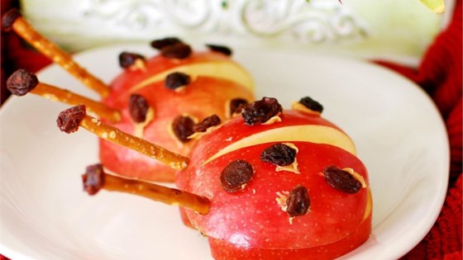

Ingredients

2 Red Apples
1 Tablespoon Peanut Butter
8 Thin Pretzel Sticks
1/4 cup Raisins

Method
- Slice apples in half from top to bottom and scoop out the cores using a knife or melon baller. If you have an apple corer, core them first, then slice. Place each apple half flat side down on a small plate.
- Dab peanut butter on to the back of the 'lady bird', then stick raisins onto the dabs for spots. Use this method to make eyes too. Stick one end of each pretzel stick into a raisin, then press the other end into the apples to make antennae.

