Ants on a Log

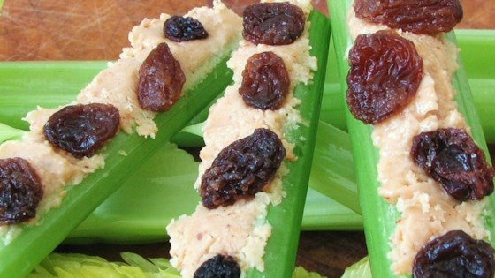

Ingredients

5 Celery Stalks
1/4 cup of Raisins
1/2 cup of Peanut Butter

Method

Cut the celery stalks in half. Spread with peanut butter. Sprinkle with raisins.

