SHARE IN OUR LEARNING: Year 3 Autumn A
English | Writing  - Our writing focus is to vary our sentences using fronted adverbials and conjunctions  - Use apostrophes correctly for both possession and contractions  - Begin to use inverted commas  - Correct use of a and an  - Explore homophones and meanings  Reading  - Apply knowledge of root words, prefixes and suffixes to read aloud and to understand the meaning of unfamiliar words  - Attempt pronunciation of unfamiliar words drawing on prior knowledge of similar looking words  - Experience and discuss a range of fiction, poetry, plays, non-fiction and reference books or textbooks  - Use dictionaries to check the meaning of unfamiliar words
Mathematics | Number and Place Value  - count from 0 in multiples of 4, 8, 50 and 100; find 10 or 100 more or less than a given number  - recognise the place value of each digit in a 3-digit number (100s, 10s, 1s)  - compare and order numbers up to 1,000  - identify, represent and estimate numbers using different representations  - read and write numbers up to 1,000 in numerals and in words  - solve number problems and practical problems involving these ideas  Addition and Subtraction  - add and subtract numbers mentally, including: a three-digit number and 1s, a three-digit number and 10s, a three-digit number and 100s  - add and subtract numbers with up to 3 digits, using formal written methods of columnar addition and subtraction  Measurement  - measure, compare, add and subtract: lengths (m/cm/mm); mass (kg/g); volume/capacity (l/ml)  Geometry  - identify horizontal and vertical lines and pairs of perpendicular and parallel lines
Science | Light and Dark  - Recognise that they need light in order to see things and that dark is the absence of light  - Notice that light is reflected from surfaces  - Recognise that light from the sun can be dangerous and that there are ways to protect eyes  - Recognise that shadows are formed when the light from a light sources is blocked by a solid object  - Find patterns in the way that the size of the shadows change
Topic | Stone Age to Iron Age (History driver)  Explore the changes in Britain from the Stone Age to the Iron Age  This could include:  - late Neolithic hunter-gatherers and early farmers, for example, Skara Brae  - Bronze Age religion, technology and travel, for example, Stonehenge  - Iron Age hill forts: tribal kingdoms, farming, art and culture
PE  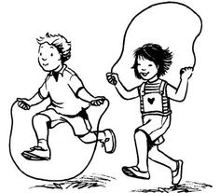 | Personal skills  - positive reactions to winning and losing  - ability to ask for help when needed  - challenging ourselves an reflecting on our strengths and weaknesses  - collaborating and working with others  Fundamental skills  - Movement patterns and directions  - Balance and stability  Sport  - High Five
Other  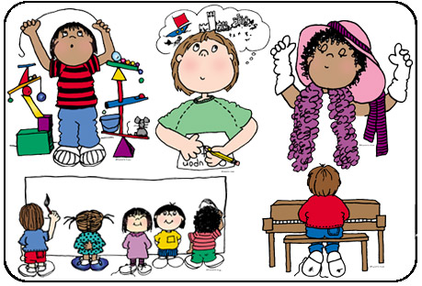 | - RE (Hindu Dharma) – What is expected of a person in following a religion or belief?  - Computing – Narrative Powerpoints  - Art – Drawing  - British Values – What is the Golden Rule?  - PSHE – Respect, belonging to groups, being a citizen around the world  - Music - keyboards

