Meat Free Monday

Vegetarian Sausage Roll Herby Diced Potatoes and Baked Beans

Macaroni Cheese Served with Broccoli Vanila Ice Cream

Tuesday

V Pork Sausage with Yorkshire pudding Creamed Potatoes, served with Carrots and Peas

Cheese or Cheese and Ham Panini served with Sweetcorn and Salad

Fresh Fruit Segments or Yoghurt

Wednesday

Beef Burger in a Bun served with Herby Diced Potato and Fresh Side Salad

Vegetarian Burger in a Bun served with Herby Diced Potato and Fresh Side Salad
Vegetables Fajitas with Savoury Rice, Sweetcorn
V Orange Jelly and Fruit

Thursday
Home Made Beef Chilli served with rice. BBQ Chicken served with Baked Wedged Potatoes,
and Sweetcorn

BBQ Quorn served with
Baked Wedged Potatoes, and Sweetcorn

Homemade Blueberry Cake/Muffin

Friday
Crumb Coated Chicken served with Chunky Chipped Potatoes, Garden Peas, or Baked Beans

Oven baked Fish Fingers
Served with Chunky Chipped Potatoes, Garden Peas, or Baked Beans

Homemade Cooks Choice Biscuits

Meat Free Monday

Margarita Pizza Rounds Served with Baked Jacket Wedges
and Sweetcorn

Chinese Style Quorn with Rice/Noodles Doughnut

Tuesday
Roast Turkey with Creamed Potato, Roast Potato, Carrot and Broccoli

Home Made Cheese Pasty, Creamed, Roast Potato and Baked Beans or Vegetables.

Fresh Fruit Salad or Yoghurt

Wednesday
V Spaghetti Bolognaise Served with Garden Peas

Garlic and Herb Chicken Pitta served with Vegetable Rice and Broccoli.

Arctic or Chocolate Ice Cream

Thursday
V Brunch Lunch
(Sausage, Beans, Hash Brown, Omelette)
V Meatball Sub
served with Diced Potatoes and Salad

V Raspberry Jelly and Fruit

Friday
Crumb Coated Chicken Served with Chunky Chipped Potatoes,
Garden Peas or Baked Beans

Oven baked Battered Salmon served with Chunky Chipped Potatoes
Garden Peas or Baked Beans Homemade Cooks Choice Biscuit

Meat Free Monday

Tomato and Mascarpone Pasta Bake Served with Seasonal Vegetables
Omelette with Baked Herby Diced Potatoes and Baked Beans
Strawberry Ice Cream

Tuesday
V Chicken Katsu Curry served with Rice

Cheese or Cheese and Ham Panini served with Sweetcorn and Salad

Fresh Fruit Segments or Yoghurt

Wednesday
V Selection of Pizza (Pepperoni/Cheese) Served with Jacket Wedges, Salad

Sweet and Sour Chicken/Quorn Served with Rice/Noodles

V Jelly and Fruit

Thursday

V Pork Meatballs in Tomato and Basil Sauce Served with Pasta and Garden Peas

Cheese Wrap served with Sauté Potatoes Sweetcorn and Salad
Vanilla and Chocolate Marble Muffin/Traybake

Friday
Chicken Goujons Served with Chunky Chipped Potatoes,
Garden Peas or Baked Beans

Oven Baked Fish Stars Served with Chunky Chipped Potatoes, Garden Peas, or Baked Beans
Homemade Cooks Choice Biscuit

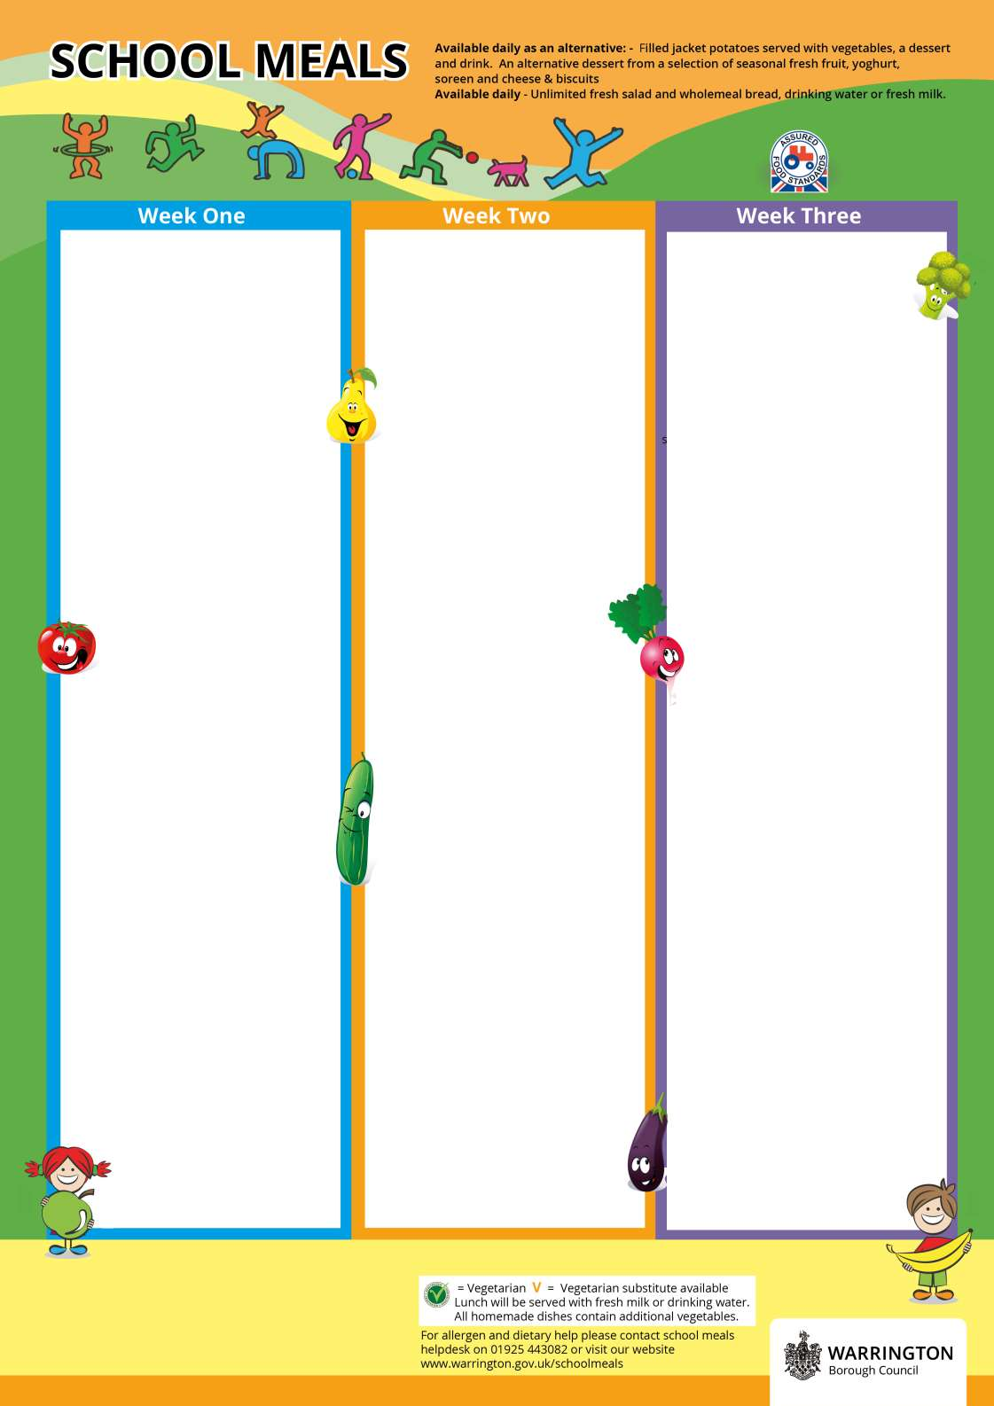
Menu Cycle Week One: 31st Aug, 21st Sep, 12th Oct, 2nd Nov 23rd Nov, 14th Dec
Menu Cycle Week Two: 7th Sep, 28th Sep, 19th Oct, 9th Nov 30th Nov, 21st Dec
Menu Cycle Week Three: 14th Sep, 5th Oct, 26th Oct, 16th Nov, 7th Dec

