SHARE IN OUR LEARNING: Year 6 Autumn 2
English | Writing  - Write effectively for a range of purposes and audiences, selecting language that shows good awareness of the reader (e.g. the use of the first person in a diary; direct address in instructions and persuasive writing)  - Select vocabulary and grammatical structures that reflect what the writing requires, doing this mostly appropriately (e.g. using contracted forms in dialogues in narrative; using passive verbs to affect how information is presented; using modal verbs to suggest degrees of possibility)  - Use the range of punctuation taught at key stage 2 mostly correctly^ (e.g. inverted commas and other punctuation to indicate direct speech)  Recount  - Developing tense structures  - Awareness of creative text structures e.g. flashback  - Application of narrative and poetic features  Persuasion  - Use a range of devices to build cohesion (e.g. conjunctions, adverbials of time and place, pronouns, synonyms) within and across paragraphs  - Consider how debates can have a variety of structures including using counter-arguments.  - Use causal language including subordinating conjunctions.  Grammar and punctuation  - Using the passive and active voice  - Developing use of subordination and conjunctions  - Recognising the function of all parts of a sentence  - Increase awareness of modal verbs  Spelling  - Hyphenated words  - Words with the /i:/ sound spelt ei after c  - Revision of prior Key Stage 2 spelling rules (This will be ongoing throughout the year and will also be representative in homework)  Reading  Classics  A Christmas Carol  Reading domains:  - 2a give / explain the meaning of words in context  - 2b retrieve and record information / identify key details from fiction and non-fiction  - 2c summarise main ideas from more than one paragraph  - 2d make inferences from the text / explain and justify inferences with evidence from the text  - 2e predict what might happen from details stated and implied  - 2f identify / explain how information / narrative content is related and contributes to meaning as a whole  - 2g identify / explain how meaning is enhanced through choice of words and phrases  - 2h make comparisons within the text
Mathematics  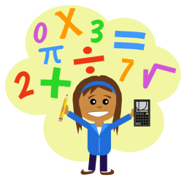 | Arithmetic  - Further develop understanding of calculation methods using four main operations.  - Recognise and apply systems for finding percentages  - Link percentages to fraction and decimal information  Place Value  - Recognise the value of all digits to 10,000,000 and decimals to 0.001  - Estimate the position of values on a number line  - Count forwards and backwards in steps of integers, decimals and powers of 10  Algebra  - Use formulae  - Generate linear sequence  - Express missing number problems algebraically  - Enumerate possible combinations of variables and use them to solve equations e.g. a + b = 10 a could be 6 and b could be 4  Negative Numbers  - Calculate intervals across zero  - Order and compare values including those below zero
Science  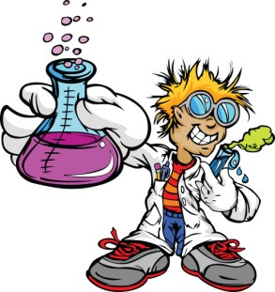 | Electricity and circuits  - Recognise how circuits can be constructed, altered and affected by components.  - Develop awareness of electrical symbols  - Use electrical diagrams to construct circuits  - Recognise why a circuit may not work from drawings and actual models  - Adjust the effectiveness and operation of components within a circuit e.g. make a bulb dimmer.  - Test the effectiveness of components and materials within a circuit commenting on their properties.  - Working scientifically – range of ongoing skills e.g. questioning, using equipment, assessing results etc.
Topic | Game and mechanism design (DT and computing)  - Investigate and review existing products  - Consider sequence of working  - Draft plans  - Work collaboratively to complete a project  - Build prototypes  - Develop cams, pulleys and the use of electrical systems  - Build accurately, including prototypes  - Develop building skills, including measuring, cutting and precision finishing  - Assess the effectiveness of their product and that of their peers  - Use programming skills to control sprites  - Make interactive elements within their games  - Consider how programming may not work and debug  - Develop deeper awareness and control of sequences, algorithms and variables.  - Consider the role of inputs and outputs to control external systems.
PE  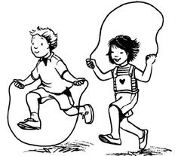 | Creativity and balance  - Developing ball handling techniques  - Considering tactics to beat my opponent  - Considering how to use team members within tactics  - Reviewing performance in order to improve  - Sequence movements which can be applied to performance and sport
Other  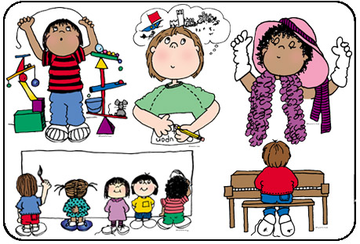 | - RE (Christianity) – Advent and symbolism  - Music – Brass – Developing knowledge and use of musical notation  - Computing – Coding and game design  - PSHE - To recognise how we can celebrate differences and how important it is in society.  - Anti-Bullying Week  - Developing understanding of social issues including racism and homophobia.  - Consider the idea of being an ‘outsider’ in modern society.  - Considers ways of improving the treatment of others in society  - Art – Painting and photography

