Newchurch Community Primary School - Share in our learning…Year 1 Summer B
English  Our class texts for this half term:  Poetry  At the Zoo by W. M. Thackeray  The Lion Inside by Rachel Bright Handa’s Surprise by Eileen Browne  Writing:  We will be using our class text to focus on the following targets in our grammar and writing:  - Compose a sentence orally before writing it  - Combine words to make sentences  - Sequence sentences to form short narratives  - Leave spaces between words  - Discuss what they have written with adults and peers  - Re-read what they have written to check it makes sense  - Use capital letters for the names of people and the personal pronoun ‘I’  - Consistently use capital letters and full stops  - Join words and clauses using ‘and |  |  | Mathematics:  Along with our arithmetic and calculation skills we will be looking at the following areas of the curriculum:  Measurement Time Geometry: Position and Direction Addition and Subtraction  We will be looking to master a wide range of targets linked to these areas, such as:  - Count in multiples of 2s, 5s and 10s  - Compare, describe and solve practical problems for time  - Measure and begin to record time  - Sequence events chronologically and use time language  - Describe position, direction and movement, including whole, half, quarter and three-quarter turns  Useful websites:  https://www.bbc.co.uk/teach/supermovers/ks1-maths-collection/z6v4scw  https://www.topmarks.co.uk/ |  |  |  | Science:  This half term our topic is…  Animals including humans  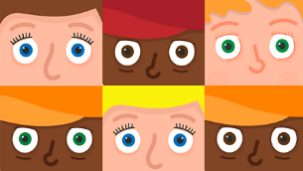  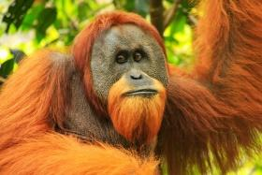  ● identify, name, draw and label the basic parts of the human body and say which part of the body is associated with each sense  ● identify and name a variety of common animals including fish, amphibians, reptiles, birds and mammals  ● identify and name a variety of common animals that are carnivores, herbivores and omnivores  ● describe and compare the structure of a variety of common animals (fish, amphibians, reptiles, birds and mammals including pets)  Useful websites:  https://www.bbc.co.uk/bitesize/topics/zrssgk7  Key Stage 1 Science | KS1 Age 5-7 | Education Quizzes
Physical Education:  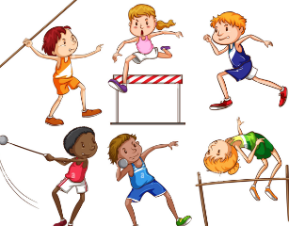  This half term the children will be developing the skills used within Athletics. | Geography:  Enquiry question  What is it like to live in Shanghai?   |  |  |  |  | DT: Wheels and Axles  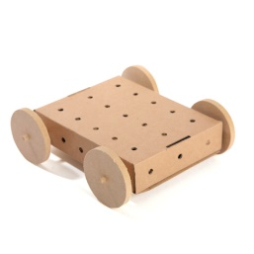  (Mechanisms)  The unit will look at wheels and axles and begin to recognise that wheels and axles are used in everyday life, not just in cars. They will design and make a vehicle with working wheels and axles.
  Religious Education: Christianity  (Church)  Key question:  How might some people show that they ‘belong’ to God?  Useful websites: https://www.bbc.co.uk/bitesize/topics/zqbw2hv |  |  |  | Music: Musical Symbols (Under the Sea)  In this new unit, the children combine all the musical concepts learned throughout Year 1 for an underwater-themed performance incorporating instrumental, vocal and body sounds.  Useful websites:  https://www.bbc.co.uk/bitesize/articles/zc2ntrd
PSHE:  Growing and changing  Unit objectives:  Recognising what makes us unique and special.  Learning about our feelings.  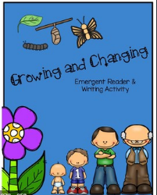  Learning how to regulate themselves when things go wrong. |  | 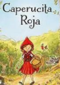  Languages:  Caperucita Roja  Targets:  Sit and listen  attentively to a  familiar fairy tale in Spanish. ∙  Use picture and word cards to recognise and retain key  vocabulary from the story. |  |  | Computing:  My friend the robot  (Fun and application)  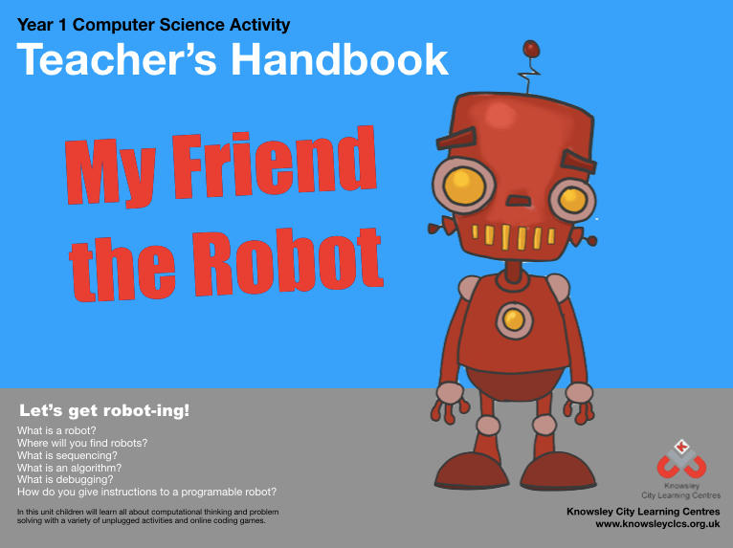  In this unit children will learn about robots; what are they, how they are used in the world around us and where would you find them? The children will learn valuable computational thinking and problem solving skills and use programmable robots.  Useful websites:  https: //www.bbc.co.uk/bitesize/clips/z28qmp3

